Poolside Pass
Applying for a poolside pass

Go to https://www.swimmingresults.org/member_options/

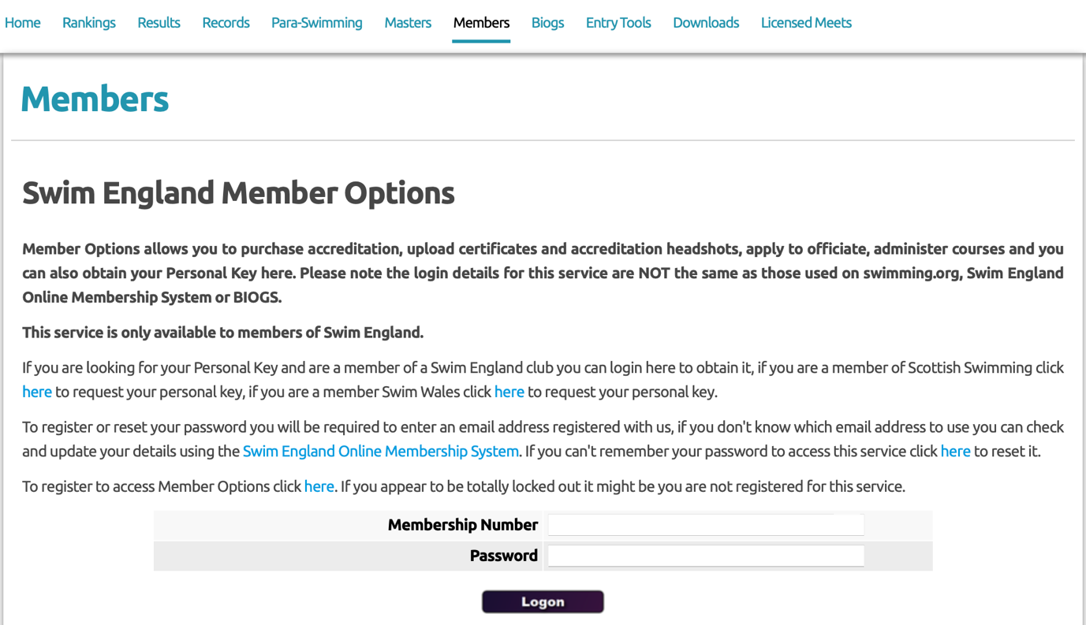

If you’re not already registered use the click here function on the webpage.

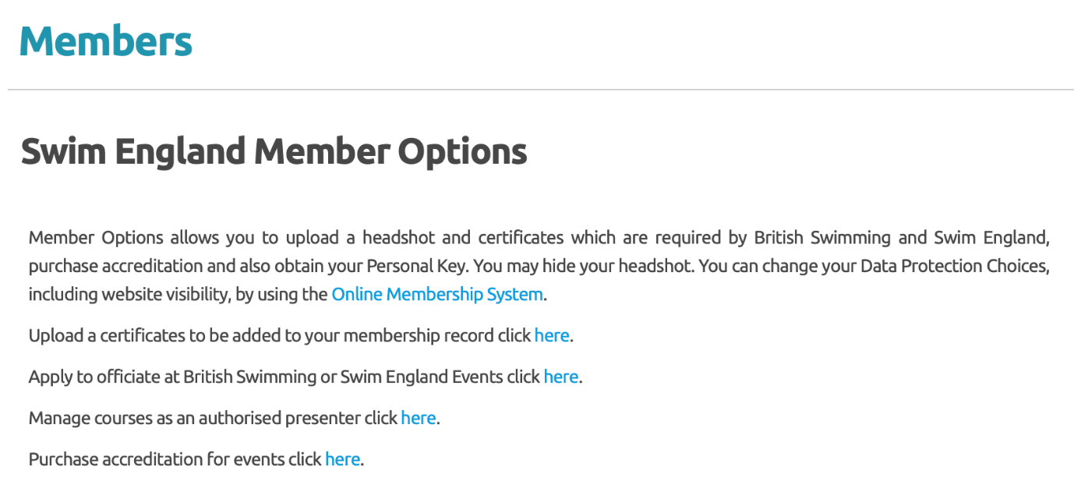
Once you signed in you’ll see this page, if you haven’t already it will ask you for a photo please upload one. Once you’ve uploaded a photo click on the purchase accreditation link.

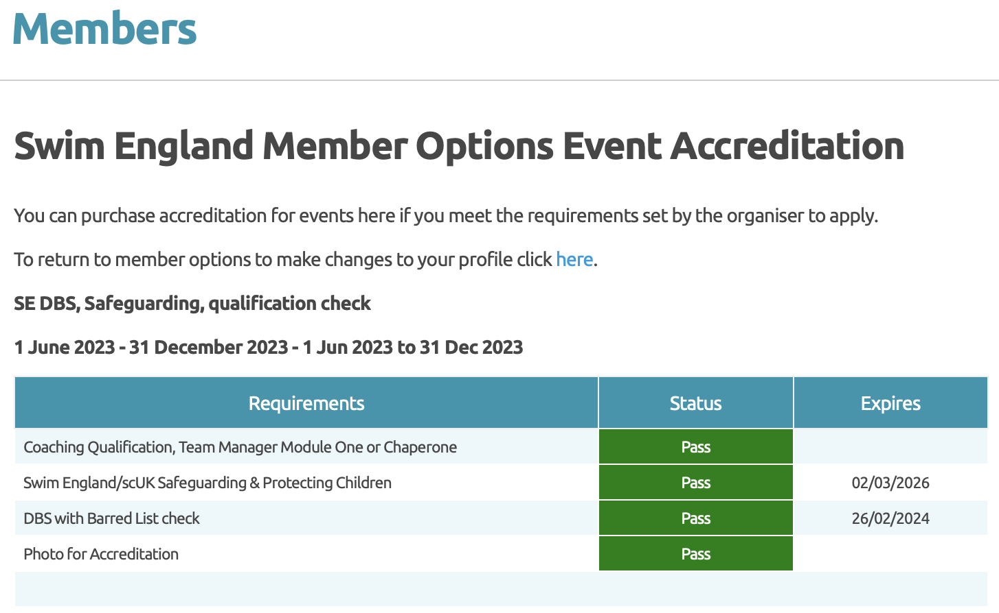
You will need to purchase the very top on as show above and download the accreditation to bring along to the meet.
You’ll only be able to purchase this if call 4 are showing Green and Pass.

