 | WILTSHIRE SWIMMING  (Wilts County ASA Founded 1907)  Affiliated to Swim England South West Region  President: Rebecca Smith (Executive Choice)

MINUTES OF THE ANNUAL GENERAL MEETING OF THE ASSOCIATION
Held on Tuesday 2nd December 2025 at 7:15pm via zoom

The Chair opened the meeting and welcomed everyone. He then held a moments silence is recognition of two former Wiltshire Members who has sadly passed away: Mike Greenan and Richard (Dick) Evans.

The meeting then continued as per the agenda published in advance.

- Apologies For Absence
Konrad Adams (Corsham, Wilts Masters Sec), Erica Hodgson (Marlborough Penguins), Paul Honeyman (RWB Otters), Melanie Sweetnam (West Wilts Diving, Past President), Paula Rutherford (Wilts Para Sec), Dennis Yeoman (Tigersharks, Past President), Sandra Yeomant (Tigersharks, Past President, Wilts CDPP/Swimming Sec), Paul Robbins (Past President), Claire Balecke (Melksham Swordfish)

Attendees
Bethan Good (BOA), Duncan Hibbard (BOA), Rebecca Smith (BOA – Wilts President & Competition Sec), Rupert Bolt (Calne Alpha Four), Matt Cruse (Chippenham), Amy Whiting (Malmesbury Marlins), Jo Jones (Marlborough Penguins), Olga Sands (Marlborough Penguins), Domonic Keogh (Marlborough Penguins) Vicky Clayton (Melksham Swordfish), Andrew Brown (RWB Otters), Jason Smith (Salisbury Stingrays), Jon Tribbeck (Salisbury Stingrays), Jez Burton (Salisbury Stingrays), Andrea Christmas (Swindon ASC, Past President, Wilts Ed & Dev Sec), Lesley Leffers (Swindon ASC, Life Member, Wilts Coaches Sec), Louise Cotton (Swindon ASC) Richard Moorhouse (Swindon ASC, Past President), Louise Moorhouse (Swindon ASC), Anthony Clark (Swindon Dolphin), Rachel Workman (Swindon Dolphin), Tom Carter (Swindon Dolphin), Chris Selby (Swindon Dolphin, Wilts Water Polo Sec), Andi Holbrook (Tigersharks), Diane Lee (Tigersharks, Wilts League Sec), Lisa Osman (Tigersharks), Michele Trevithick (Tigersharks, Wilts Officials Organiser), Andy Ryczanowski (Tigersharks, Wiltshire Chair), Geoff Peace (Tigersharks, Wilts President Elect), Karl Mutton (Tigersharks, Wilts Treasurer), Dave Jones (Tigersharks, Wilts Officials Secretary), Jaan Nellis (Trowbridge), Michele Greenan (Trowbridge, Wilts Secretary), Mariusz Hoszko (Warminster & District), Stephen Pyne (Westbury)

- Minutes of Annual General Meeting held on Saturday 29th Nov 2024
  - The Chair asked all attendees if there were any comments on last year’s AGM minutes (these can be found on the website and via this link). There were no comments made, therefore The Chair proposed these be accepted by the attendees as a true record. This was accepted unanimously by show of hands.

- Matters Arising
  - There were no points arising from the previous minutes.

- Chair’s report
  - The Chair gave a report which these are bullet points from it. The full report can be seen in Appendix A.

  - Emphasis on volunteer reliance across county aquatics and growing difficulty recruiting volunteers; clubs encouraged to recruit and mentor new volunteers. Discussion highlighted a volunteer vs paid-membership two-tier model used by another club, but Chair expressed concern about monetizing volunteer tasks.

  - County objectives: support clubs, volunteers and swimmers via funding, education, bespoke training, bursaries (new training tab on Wiltshire website to centralize information). New 40% bursary for athletes invited to regional/national talent pathways.

  - County Development Pathway: ran March–July with 24 swimmers and 5 staff (two face-to-face, three online); new lead coach for next year; call for more assistant coaches and team managers.

  - Recognition of Paula Rutherford (Participation & Community Coach of the Year—Southwest; national bronze) and The Link Centre (national gold — Health Impact category for GP referral/health-wise programme).

  - Personal activity summary: attended 20 committee meetings, 8 regional/national Chairs meetings, 4 workshops, 5 club visits, 87 officiating sessions (170 hours across 49 days), mentoring, training and events; won Southwest Region Technical Official of the Year and was a national finalist.

  - Masters: three-round competition (Trowbridge, Swindon, Royal Box); attendance 70–90/round; international representation (Singapore World Masters); inter-county: 3rd regionally, 16th nationally.

  - Diving: two clubs (West Wilts Diving, Highworth/Highway Phoenix), small numbers; clubs active regionally/nationally; workforce development for coaching/judging; thanks to key volunteers (Melaine Sweetman, Irene Aldridge).

  - Artistic Swimming: single thriving section at Calne Alpha 4 (circa 40 swimmers) with regional medals; volunteer shortages noted.

  - Water Polo: two clubs (Bradford-on-Avon, Swindon Dolphins) competing in Bristol West Leagues; Dolphins 2nd and President’s Cup winners; possibility of re-forming a Wiltshire team under discussion.

  - Open Water: previously no county committee; good regional results (27 athletes, 13 regional age-group champions); five volunteers now recruited to rebuild committee.

  - Para swimming: hub at Swindon ASC under Paula Rutherford; growing participation and classification numbers; athletes representing at national and international events.

  - Swimming (pool): County Championships held Jan–Feb across multiple venues including Bath University (long course); Development meet (10–13 year old's) restarted after four years; Wiltshire League ran with two rounds May–July and finals in September (16 teams across A and B finals). County team finished 14th in Div 2 at National Inter-County event.

  - Overall: County activities surviving but stretched; repeated thanks to volunteers and clubs; call for increased engagement.

  - Michele Greenan thanked The Chair for his report and for all the work he does throughout the county. This was endorsed by all attendees by show of hands.

- Financial State
  - Karl gave a report into the county finances, and the following are highlights from his report. A more detailed version of the report can be found in Appendix B.

  - Membership trends: club compete steady but declines in club train and club support since 2021; concern about lower junior numbers.

  - Statutory year draft accounts: broadly similar year-on-year. Key points:
    - Education & development bursaries underused (only six clubs claimed); encouragement for clubs to use available bursaries.
    - Competition accounts anomaly: double charge for inter-county travel/coaches due to late invoicing, affecting 2025 figures.
    - Increasing pool hire costs affecting recoverability.
    - Trophies are listed at historic values; executive pursuing professional re-valuation (values likely from late 1980s/early 1990s).
    - Cash-in-hand item to be reduced as transaction methods move to digital; cash will be banked and future years will show digital receipts.
    - Higher debtors in 2025 due to late payments for Wiltshire League and county events; monies have since been collected following reconciliation and chasing.
    - Overall reduction in reserves of approximately £6,000 year-on-year. Discussion on holding reserves and potential increased bursary spending; proposals invited from clubs on additional use of funds.

  - Orange Stripe reappointed as independent examiners for accounts; membership accepted the financial report unanimously.

- Competitions Report
  - County swimming age-group championships ran successfully; Bath University used as long-course venue for some events; 100m IM held separately at the Link Centre; relays reinstated in championship programme.

  - Wiltshire League: second/third year of new format; finals at Bath University (Level 4 license); winners noted (Swindon Dolphins Gala 2; Marlborough Penguins Gala 1).

  - National Inter-County event: Wiltshire finished 14th in Division 2; over half swims were personal bests; 16 swimmers earned first-time caps.

  - Masters: regional inter-county placed 3rd (as previously reported).

- Presentation of Awards
  - Swimmer awards:
    - Female Swimmer of the Year: Sophie King (Swindon Dolphin)
    - Male Swimmer of the Year: James Trevithick (Tigersharks)
    - Para-athlete of the Year: Ella Williams (Swindon ASC)
    - Club of the Year: Chippenham ASC

  - AGM Awards (limited nominations received this year):
    - Leyland Cup (coaches/teachers): 1st Chippenham, 2nd Bradford-on-Avon
    - John Ovens Learners Trophy: 1st Chippenham, 2nd Bradford-on-Avon
    - Orum Trophy (Stages 8–10 & awards):1st Chippenham, 2nd Bradford-on-Avon
    - Doreen Clark Award (age group points, 10–13) — Salisbury Stingrays.

Encouragement for clubs to increase future nominations for swimmer & club awards.

  - Special presentations
Dolly Rice Award: Rebecca Smith proposed and seconded; citation highlighted Rebecca’s 40-year involvement, competitive achievements (including World Masters medals), extensive voluntary roles (Competition Secretary, Masters secretary, county records, inter-county liaison), coaching, officiating and teaching. Rebecca Smith to receive formal presentation in January event.

Life Membership: Michelle Greenan proposed for life membership in recognition of long service (trophy steward role managing >300 trophies, 13 years as county secretary, calm and equitable administration through difficult periods). Motion carried by members; Michelle remains involved with Education & Development, CDPP/Swimming, and Emergency committees.

The citations for both awards can be seen in Appendix C.

- Election/Confirmation of Association Officers
  - Officers confirmed/appointed (show-of-hands approval):

  - County President: Geoff Pearce (Tigersharks) — nomination from Tigersharks; acceptance and citation read. Geoff has long club service (since 2007), multiple executive roles, experience navigating pool closures, former county and regional treasurer.
  - Chair: Andrew Ryczanowski re-nominated for third term and supported by club; prepared to continue.
  - Secretary: Lesley Leffers nominated and recommended to replace Michele Greenan as county secretary; supported by club Swindon ASC.
  - Treasurer: Karl Mutton re-appointed and supported by club (Tigersharks).
  - President-elect: Bethan Good nominated (Bradford-on-Avon) and approved.
  - Welfare officers: both incumbents Joanne Paton & Steve Boocock consented to continue.
  - Regional board member: vacancy to be held pending regional stability; Geoff (regional treasurer) will cover regional duties with chair as short-term standby.
  - Assistant Secretary: vacancy; on hold to see if needed, but volunteers welcomed.
Full Nomination list can be found in appendix D
- Committees updated; nominations and vacancies noted (many committee members continuing; specific committees and secretaries include):
  - Emergency Committee: Paul Robbins, Andrew Brown, Michele Greenan.
  - Finance Committee: led by Treasurer; four nominated members.
  - Education & Development (Ed & Dev): Secretary Andrea Christmas; members include Duncan Hibbard and Michele Greenan; two vacancies remain.
  - CDPP & Swimming Committee: Secretary Sandra Yeoman (regional rep); seven committee members listed.
  - Coaches Panel: head coaches panel with Secretary Lesley Leffers and regional rep Richard Smith.
  - Officials Panel: Secretary Dave Jones; regional rep Paul Robbins; Michelle Trevithick is county officials coordinator.
  - County Competition Secretary: Rebecca Smith to continue.
  - Wiltshire League Committee: joint secretaries Diane and Rob (plus management committee members Duncan Hibbard and Richard Smith to be added to published documentation).
  - Open Water Committee: newly formed team (Sam, Chris, Catherine, Kelly and Laura); Rebecca Smith to act as regional rep liaison.
  - Master’s Committee: Konrad Adams as secretary/regional rep (co-opted); committee members listed.
  - Diving Committee: Melaine Sweetman continuing as secretary; regional committee no longer exists so no rep required.
  - Artistic Swimming: Clair Murphy and 3 committee members listed.
  - Para swimming: Paula Rutherford continuing; Dean Fouracre joins; three vacancies exist.
  - Water Polo: Chris Selby, Jim Robbins, Clive Milner (Bradford-on-Avon); Swindon Dolphins representation requested.
All committee member appointments were put to the meeting and endorsed by a show of hands. Full list of committee members can be found in Appendix E.

- Renewal of Constitution
  - Two minor amendments to the constitution were proposed to include the position of Assistant Secretary in Rule 7.2.1 (under rule 7 Election of executive officers) and Rule 9.2.5 (under rule 9 AGM meeting rules). Both were approved by show of hands.

The rules affected with both original version and changed version can be seen in Appendix F.

- Presidential Handover
  - Outgoing President Rebecca gave brief remarks thanking clubs and the executive; enjoyed award presentations and county activities.

  - Incoming President Geoff Pearce accepted nomination, gave short address emphasizing desire to be poolside and engage with clubs; thanked Tigersharks and clubs for support.

  - Club representatives and Past Presidents offered congratulations and welcomed Geoff.

  - Past presidents and execs acknowledged Michele Greenan’s service and gave a small token as thanks for all her service as County Secretary.

- Proposed dates for 2026 Executive Meetings - All meetings are for 2026 are 7pm start and unless otherwise stated will be via Zoom.
  - Wednesday 24 February 2026 – Management Meeting
  - Tuesday 21 April 2026 – Full Executive with Clubs Meeting
  - Monday 18 May 2026 – Management Meeting
  - Wednesday 15 July 2026 – Management Meeting
  - Tuesday 15 September 2026 – Full Executive with Clubs Meeting
  - Monday 02 November 2026 - Management Meeting

- Date of 2026 A.G.M. - Tuesday 24th November 2026 @ 7:15pm

- Closing remarks
  - Chair thanked attendees and wished all a prosperous festive season. Appreciation expressed to Andy (Chair) for his leadership.

- Key action points and follow-ups
  - Clubs to consider recruitment and mentoring strategies to address volunteer shortages.
  - Clubs encouraged to use education & development bursaries (only six clubs have claimed so far); county will publicise this through the training tab on website.
  - Competition committee to encourage increased nominations for AGM awards next year.
  - Finance: pursue trophies re-valuation; consider options for using reserves (e.g., increased bursaries); continue chasing late payments (recently resolved).
  - Open Water: newly formed committee to produce plans and events for next year.
  - Vacancies to fill: Several Ed & Dev and Para committee vacancies, Water Polo representation from Swindon Dolphin.
  - Publication updates: include Duncan and Richard in Wiltshire League management documentation and publish updated committee lists.

- Decisions recorded
  - Minutes of last AGM accepted.
  - Financial report accepted; Orange Stripe reappointed as independent examiners.
  - Election and appointments of officers and committee members approved by show of hands.
  - Constitutional amendments (adding Assistant Secretary references) approved.
  - Dolly Rice Awarded to Rebecca Smith; Life Membership awarded to Michelle Greenham.

Meeting closed at 8:35pm

Appendix A
Wiltshire Swimming AGM 2nd December 2025 – The Chair’s Report

I want to start my report by highlighting all the time and effort people involved with running Aquatics at Club level and within the County structure have put in. We are in the main all volunteers and those who are paid started out as a volunteer. We’ve all started out because we wanted to ensure our family, or our families have wanted us to be safe in and enjoy the water that covers 71% of the earth. Before we know it, we have put our hands up to help, and we have become a volunteer. We have a few of us that it is more than 50 years others it is just a few. So, a big thanks you to all from me and the Executive Officers.

From the National Chairs Forums I’ve attended this year, a frequent concern is the shortage of volunteers and how difficult it is to recruit them. This is a big problem and it’s not getting any easier. We in Wiltshire are no different as will be demonstrated later in this AGM when we review and hopefully approve the County Officers and committee positions. These you will see are mainly the same faces as before. To those I say a big thank you. To you all, can I ask you to think about how we can encourage those new into your clubs to lend a hand and help keep our sport going. All suggestions are welcome. On Wednesday night I attended the latest Club Development Forum, and the question of volunteers was raised again. This time a chairperson from the north east asked if volunteering was obligatory or an option? The debate went on for some time and some clubs said they offered a two-tier membership, one where a family member volunteers and another where the family opt out of volunteering. The were asked “what was the main difference in the membership?”. The answer was given straight “about £300 per year. We use the money to pay someone to do the jobs no one would volunteer for”. I can see why they have done this, but this should not be the way to do it. If we did this, I could be a wealthy person.

As for me, I have had another productive year; 20 committee meetings, 8 regional and national chairs meetings, 4 workshops, 5 club visits, 87 sessions of officiating totalling 170 hours over 49 different days, plus countless mentoring sessions, phone calls, zoom conferences, on-line training and sadly 2 funerals (Mike Greenan, Trowbridge; Dick Evans, Chippenham). I was surprised and very pleased to be nominated as South West Region Technical Official of the Year and even more surprised to win it. It made me feel very humble that someone took the time to write such a nice citation as I aways feel that I was just doing what anyone would do. I would also like to mention Paula Rutherford who won the Participation and Community Coach of the Year award, at the same event. Both she and I went to Birmingham University last Saturday (29th November 2025) for the National awards. I am pleased to say that Paula won a bronze award in her category, well done. I had to be content with being a finalist and enjoyed a good day out. It is also worth noting the Link Centre, Swindon, were awarded a gold in the category of Health Impact. This was for identifying the benefits of swimming in the Healthwise GP referral programme and providing high-quality sessions led by qualified instructors. This have seen transformative results for participants with chronic illnesses.

I would like to thank, Maurice Clever, past President of Wiltshire and Wiltshire life member, for your outstanding leadership and the positive impact as this years’ Regional President. You will be a tough act to follow.

As a County our aim and objectives are to support clubs, volunteers, and swimmers in developing the skills to ensure they can achieve their potential within this sport. We aim as a county to do this in the provision and funding of Educational and Development opportunities with Courses, CPDs, personal mentoring, and development pathways programmes. We will deliver this through advertising what courses are available, creating bespoke opportunities when needed, and providing funding through bursaries. For more details and how to apply, please see the new training tab on the Wiltshire website.

We as a county also provide high level championships, development meets, team competitions and a county development programme for talented athletes. As well as these we will aim to support the Regional and National talent pathways by providing a new 40% bursary for those invited on to these programmes. All these opportunities will be across all disciplines under the Aquatics umbrella.

Last year, I asked for you all to engage in the development of our athletes, our coaching staff and Team Managers by supporting our county development programme. This proved to be a little slow in getting off the ground and with a lot of effort did have some new faces. Unfortunately, the numbers were small which meant the opportunities for the athletes were limited and cause the selection team a lot of work. This is still in the early stages and again I would like to ask you all to help by encouraging new coaches and Team managers to get involved with the few county activities we do.

The Development pathway programme did run March to July with 24 swimmers and 5 support staff. This consisted of 2 face-to-face sessions and 3 on-line workshops - I do remember logging-in from Paris to set up the Lead Coach with my zoom account for the Nutrition workshop; see I am committed to making this work (or I should be I hear some of you saying). This year we have a new lead coach who will be guided by a more experience Senior Coach. We are looking for and will encourage you to recommend new Assistance Coaches and New Club Coaches to participate and gaining a wealth of experience from coaching different level of swimmers. Also, we are looking for Team Managers to help at the Face-to-Face sessions. Depending on the number of coaches we get will depend on how many swimmers we can invite, so please encourage your coaches to step up.

Now for a quick review of Disciplines:

Masters: The Wiltshire Masters competition consists of three rounds held in Trowbridge, Swindon and Marlborough College pools. Numbers competing averaging between 70-90 per round.

Two brave swimmers from Wiltshire went to the world masters in Singapore. They were Chris Jessup (Salisbury) and Jane Snedden (Warminster) and Jane came back with a bronze medal from her 50m backstroke.

A small team of master swimmers went to Regional Masters in October at Millfield which was poorly attended overall. This could have been because the National Master in Sheffield was so close being only two weeks later, A strong squad from Wiltshire attended with Tigersharks sending a strong team, and single representative from Warminster, Corsham, Melksham and Swindon Dolphin. I must also mention those with dual registrations from Swindon ASC, BoA, who were part of the Tigersharks numbers for the event. The group came back with lots of medals:
- 5 Gold Medals
- 5 Silver Medals
- 7 Bronze Medals
Rounding up the year saw Wiltshire’s Masters team go to Millfield in November for the Inter County Team event. They finished a creditable 3rd in the Region and 16th
at the National level. Well done to them.

Diving: We still have two clubs within Wiltshire at present, West Wilts Diving and Highworth Pheonix. Both clubs are still operating but numbers in comparison to other clubs are small.

West Wiltshire Diving are still actively participating at the Swim England Regional and National event with one diver competing internationally. The workforce is working on their skill to enable them to coach, judge and support at Aquatics GB events.

They have had no update from the pool for 18 months and therefore have nothing to report on when we will close. We are operating on a minimum and supporting our divers throughout their journey.

Highworth continues to compete at local club competitions and have younger divers coming through. And of course, Irene is still at the heart of the club.

These two clubs are led by Melanie Sweetman and Irene Aldridge, who I sincerely thanks for keeping this discipline going.

Artistic Swimming: Within the County we only have one club but a thriving squad of 40 swimmers under the guidance of Clair Murphy and Lynne Eddy at Calne Alpha. The club is competing very well and has won medals at a SWR Competition. Gradings continue and swimmers are doing very well. However, the club is experiencing the same issues as Swimming Clubs with getting volunteers for all roles, Officials, Coaching, Team Managing.

Water Polo: There are still only two squads in the county; Bradford-on-Avon and Swindon Dolphins. They both compete in the Bristol and West leagues.

The water polo season has finished, and I am pleased to say that our two clubs have performed well with Bradford finishing fifth in League Two and Swindon Dolphins finished second. Swindon Dolphins also won President’s Cup.

Participation numbers are stable and prospects for forming a Wiltshire team are under consideration. However, this could be challenging due to the clubs needing to get together, also they are involved with clubs outside of the county.

To promote cross discipline interest the committee have offered to clubs in Wiltshire to come along and give taster sessions. Any Clubs interested in this please contact Chris Selby

Open Water: We have operated without a committee in the county for some time and swimmers only had the regional championships to enter, which fortunately for us is held at the Cotswold Water Parks. Having said this, we had 27 athletes competing and produced 13 Regional Age Group champions. A number of these went on to the national Competition and swam well.

Next year we have found five volunteers to be involved with open water, so watch out for more.

Para Swimming: The main hub in Wiltshire is still Swindon ASC under the guidance of Paula Rutherford our County Representative on the Regional Committee. Numbers are growing within the county and so are the numbers who have been classified. This will mean more will consider entering our Championships, I will look forward to seeing this in 2026.

Para-athletes from Wiltshire have qualified and taken part at the British Championship, English Summer Nationals, Winter Regionals and the European Downs Championships where they came away with a few medals.

I would like to thank all the clubs with Para-Athletes for including them in their squads and to make them feel included and valued as members of our aquatic family.

Swimming: 2025 saw the County Championships run in January, and February. A big thank you must go to the Events Team and all the volunteers that helped, for all the hard work behind the scenes to deliver these Championships. This is, and always will, be a big part of the County Programme. I must thank clubs who gave up their pool time to enable this event to happen, with sessions held in Salisbury, Link Centre Swindon, Marlborough College and for the first time at the Bath University. This was a big change for us and big learnings for the Events Team and for the University as they have not held events there for some time.

In May for the first time in over 4 years saw the county deliver a development meet for 10- to 13-year-olds in Salisbury. This was a one-day event delivering 50s & 100s in all four strokes, 200 freestyle, and 100 & 200 IMs. It was a great success and well supported. Following numerous wash up meetings with clubs and coaches we will be repeating this again next year.

The Wiltshire League was repeated this year with two rounds crammed into the period from May to July. I would like to thank all the people who were involved in organising the preliminary rounds and to the swimmers for providing such great atmosphere and exciting races. The finals in September saw 16 teams compete in the A & B finals. This was up on the previous year as we only had 14 teams. Champions were Swindon Dolphins in the A final and Marlborough Penguins in the B final.

This competition is something we all enjoy and the feedback from swimmers is this is something they enjoy doing as well. However, the organisation of this even relies on someone in each club volunteering to act as a liaison with the other clubs in their group and to get dates sorted. I am pleased to say, the 2025/26 season after a lot of discussion we now have dates for the 4 groups for Round 1. I would love to see dates for round 2 sorted for May to July 2026 sooner than later, please keep cooperating with each other.

A county team was sent to the Swim England National County Team Event in Sheffield in October and we finished 14th (one place higher than in 2024. Well done to the volunteers that went. I also want to mention Rebecca Smith who went as County President; she also fulfilled the Team Manager 2 roll at the hotel and was heard to complain most vocally about having to sit poolside to watch the racing with all the other Presidents when she longed to be with the team up in the seating.

In Summary

I hope you can see that as a county; we are trying to keep the Aquatics sports alive, and with the help of some hard-working individuals it is surviving (in some areas only just). I would like to thank all those individuals for everything they put in, as without you these disciplines will die. I also like to thank all of you, for all the support you give to our sport. I want to thank everybody who is involved with all the committees, without you the county activities would not happen. I also want to thank all the Club Chairs, Secretaries, Treasurers, committee members and all the volunteers who turn up in their own time to help run this sport for all the swimmer of the county.

Thank you all so very much, the County Executive Officers and I wish you all a very successful season ahead.

Appendix B

FINANCE REPORT

Summary Financial Report – Year to 31 August 2025

SWIM ENGLAND MEMBERSHIP

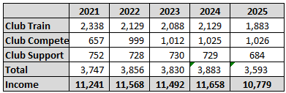

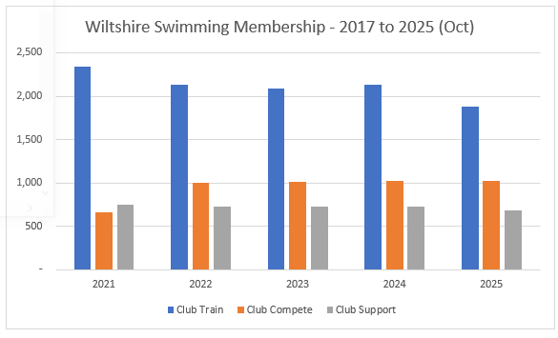

Monies collected so far from ASA total £10,779 [6 payments received in 2025], agreeing to the Swim England Communications.

INCOME / EXPENSES – Year to 31 Aug 2025
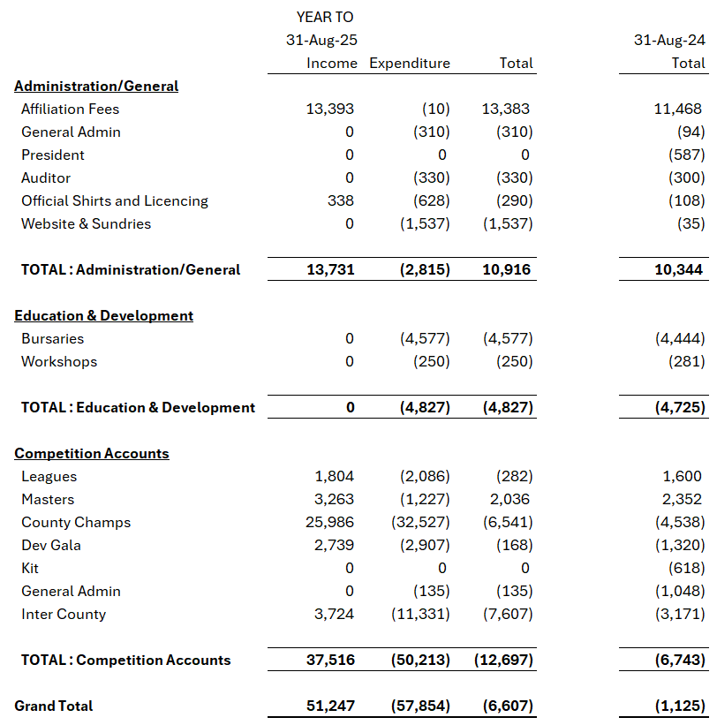

Included within the above affiliation fees are £600 relating to a bursary receipt, and £1,000 in trading income. The membership element is therefore £11,793. It should be noted that Swim England’s year is calendar based, whereas our year runs 1 Sep to 31 Aug. It makes interpreting swim England receipts somewhat confusing as some of the receipts shown in the 2024 year for Swim England are in the above table, and some in the 2025 column are not shown as they are received after the end of the reporting year.

The above report is based on the data set submitted to Orange Stripe for Verification and so is presented on an accrual’s basis, in line with statutory format.

This means that I have adjusted for monies owed to Wiltshire (Debtors), monies owed by Wiltshire (Creditors), Changes in stock holdings (Medals/Trophies) etc.

BALANCE SHEET AS AT 31 AUG 2025

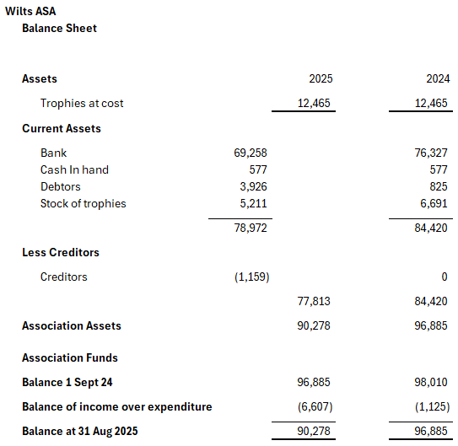

The balance sheet shows the cash in the year has depleted, by approx. £7k, however you will notice that the debtors’ figure has risen by almost £4k which represents clubs that had not paid for their entries into the Wiltshire League 2025, nor the Counties 2025 events. This is something that has been discussed at Financial Executive meetings, the outcome of which will be the meet organisers will be working more closely with the treasurer to ensure that payments are made with entry for all events going forward. In future years therefore this number is expected to reduce.

OTHER MATTERS
This is my first full financial year as treasurer and there are several things that I am working on to get a greater understanding of, or to tidy up as we move into the new financial year.

- We have many Trophies held on the books. My understanding is that these were last professionally valued by Deacons of Swindon at some point in the 1980s so the value shown may be substantially different today. Gold and precious metals are exponentially higher in value today that at any point, so I have asked for a catalogue of these trophies to be done, and where relevant an up-to-date valuation carried out. Once we have ascertained the value then we can discuss further the options of what to do with the trophies. Considerations being (but not limited to), showing in a trophy cabinet, putting back into supply, selling. There is clearly a large amount of history tied up in these, but we should be open to a discussion on how we best utilise these assets. They reside now in a loft and have been there for a little while.

- Cash in hand monies. This existed previously to provide ad hoc petty cash and a float to assist with door entry change for spectator allowed events. The modern approach which has been in place now for 2 years has been to use the sum up card machine lent to Wiltshire by Tigersharks. Monies are simply passed through from club to county, and no profit is made by Tigersharks on the transaction. This has been very successful and goes hand in hand with the cafes that are often on site also only operating on a non cash basis, so people are used to using their cards for these micro transactions. We have discussed and agreed that during 2025/2026, the cash float will be paid back into funds and no further petty cash floats will be held.

- Trophy Stocks. As we start to look at the plans for 2025/2026, we will be putting a budget in place for medals and trophies, we have historically always purchased from one gentleman who is now of a retirement age, and we do not know how much longer he will be able to supply Wiltshire with its medals. We will therefore be encouraging that when we hold events we start to think about ordering in for the event itself and not stockpiling medals which is both burdensome and costly to do. I would welcome data to enable me to help plan out when we should next be thinking about ordering medals. Ideally, I am looking for the number of medals utilised at each of the events listed below. Stocks on hand at the end of August 2025 were: -

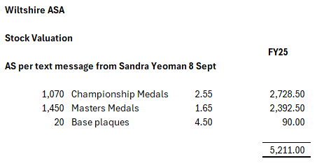

AND FINALLY…
I am delighted that following an intensive period of communications between myself and all the club treasurers, all outstanding monies for 2025 events (shown as debtors in this report), have now been collected. I thank the clubs for working with me to resolve and for doing so in a speedy manner.

A breakdown of bursaries is shown in the table below, it should be noted that only 6 clubs claimed for bursary support in the year. Help and guidance are available for clubs to ask for support, and I recommend that they reach out if they are unsure.

Bursaries by club

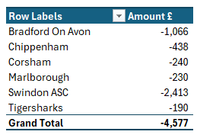

Appendix C
Nomination for the Dolly Rice Award

Proposed by – Sandra Yeoman and Seconded By Michele Greenan

I am delighted and proud to be able today to formally propose the name of Rebecca Smith as a recipient for the Dolly Rice Award.

Rebecca joined Bradford on Avon Swimming Club as a 5-year-old. At the age of 8yrs she was awarded a trophy for the most promising Under 9 swimmers. They got that right didn’t they. She quickly progressed through the system of club galas, Leagues and into County Age Groups and Championships. I had noticed her progress and then from the age of 13 coached her in Red Group at the yearly Easter Courses for the next 6 years.

Due to the fact that it was the extensive work covered by her mum Margaret, who was the glue which held Bradford together, as well as being County President and Competition Secretary. Rebecca was immersed in all aspects of swimming; teaching; coaching; administration and officiating. In 2018 she officiated at The Island Games in Gibraltar.

Rebecca has now been an ASA/SE member for 40 years, still competing at Championship level and placing in the top 3 of many events. She is a prolific and committed Masters swimmer, and this culminated last year with a silver at the World Masters Championships in Tokyo. She has twice been awarded County Swimmer of the Year and is the highest decorated girl with county badges. For years this stood at 25 for Sally Hudson and Joanne Ovens. Today Rebecca’s tally is 29!

After Uni, Rebecca qualified as a Science Teacher, and finding “spare” time from somewhere, accepted the role as Secretary of the Masters Committee in 2011 a role she held for 6 years and is still today on that Committee.

In 2015, due to the early demise of her mum, Rebecca decided to take on her job as Competition Secretary (only the 5th person since 1967). This was at the time that due to the role being slightly broken up and was no longer classed as an Officer’s position. But it is much bigger than many Sub-Committee Secretary roles. She is responsible for the Competition Committee, AGM Swimming Awards, Swimmer of the Year Competition, County records and issuing of Certificates, all Inter County events including the yearly SE Inter County at Sheffield where she is Team Lead and County liaison for Development Programme.

I do not know how she finds the time, still teaching and coaching at Bradford, still swimming, still working for the sport. What I do know is how lucky we are to have her.

I cannot think of anyone more worthy to receive the Dolly Rice Award.

Proposal for Life Member

Proposed by – Sandra Yeoman and Seconded by Lesley Leffers

Michele Greenan’s first appointed role within Wiltshire was to be Trophy Steward. A massive task tracking, arranging engraving and transporting trophies to events for presentations, a total of well over 300 trophies. She did this job for several years.

In 2013 she took over as County Secretary for Wiltshire, a role in which she has just completed her 13th year. In that time, she has always dealt with whatever came to hand with a calm, equable and common-sense approach, establishing a superb working relationship with all the sub-committee secretaries with whom she worked.

Even throughout the last difficult 24 months she has always been at hand with help and advice.

Having decided it is time to relinquish the role, we will miss her calm approach to the job.

Thankfully she is not vanishing over the horizon but will stay involved with both the Education & Development and CDPP/Swimming Committees, as well as staying on the Emergency Committee.

We feel that you are a worthy recipient as a Life Member and are delighted to make this proposal.

Appendix D

Nomination for Wiltshire Swimming Posts – AGM

Position | Holder | Nominators - Comment
President | Geoff Pearce | Tigersharks ASC
President Elect | Bethan Goode | Bradford on Avon SC
Chairperson | Andrew Ryczanowski | Tigersharks ASC
Secretary | Lesley Leffers | Swindon ASC
Treasurer | Karl Mutton | Tigersharks ASC
Welfare Officer 1 | Joanne Paton | Management Executive
Welfare Officer 2 | Steve Boocock | Management Executive
Regional Board Member | Vacant | Held pending; due to emergency recommendations
Independent Auditors | Orange Stripe | Recommended by Finance Committee
Asst. Secretary | Vacant

Appendix E

Nomination for Wiltshire Swimming Posts – Sectional Committees

Position | Holder | Nominators - Comment
Emergency Committee
Emergency Comm 1 | Paul Robbins | Management Executive
Emergency Comm 2 | Andy Brown | Royal Wootton Bassett Otters
Emergency Comm 3 | Michele Greenan | Andrew Ryczanowski & Lesley Leffers
Finance Committee
Finance Secretary | Karl Mutton | By Default, as Treasurer
Finance Comm 1 | Andrea Christmas | Swindon ASC
Finance Comm 2 | James Hobbs | Bradford on Avon
Finance Comm 3 | Andy Brown | Royal Wootton Bassett Otters
Finance Comm 4 | Richard Moorhouse | Swindon ASC
Education and Development Committee
Ed & Dev Comm Sec | Andrea Christmas | Voted for by Education & Dev committee
Ed & Dev Comm 1 | Duncan Hibbard | Bradford on Avon
Ed & Dev Comm 2 | Michele Grennan | Sandra Yeoman & Lesley Leffers
Ed & Dev Comm 3 | Vacant
Ed & Dev Comm 4 | Vacant
CDPP/Swimming Committee
CDPP/Swim Comm Sec | Sandra Yeoman | Voted for by CDPP/Swimming Committee
Swimming Regional Rep | Sandra Yeoman | Voted for by CDPP/Swimming Committee
CDPP/Swim Comm 1 | Lisa Osman | Tigersharks ASC
CDPP/Swim Comm 2 | Gary French | Tigersharks ASC
CDPP/Swim Comm 3 | Michele Greenan | Lesley Leffers & Sandra Yeoman
CDPP/Swim Comm 4 | Tim Sadler | Lesley Leffers & Sandra Yeoman
CDPP/Swim Comm 5 | Dave Leonard | Swindon ASC
CDPP/Swim Comm 6 | Paul Robbins | Lesley Leffers & Sandra Yeoman
CDPP/Swim Comm 7 | Jayne Hart | Michele Greenan & Dennis Yeoman
Coaches Panel
Coaches Secretary | Lesley Leffers | Voted by Wiltshire Coaches
Coaches Regional Rep | Richard Smith | Voted by Wiltshire Coaches
Officials Panel
Officials Panel Sec | David Jones | Voted for by Wiltshire Officials Panel
Officials Regional Rep | Paul Robbins | Voted for by Wiltshire Officials Panel
Officials Panel 1 | Gary French | Tigersharks ASC
Officials Panel 2 | Michele Trevithick | Tigersharks ASC (Officials Coordinator)
Officials Panel 3 | Andrew Brown | Royal Wootton Bassett Otters
Officials Panel 4 | Richard Moorhouse | Andrew Ryczanowski & Lesley Leffers
Competition Committee
Competition Secretary | Rebecca Smith | Voted for at Competition Meeting
Wiltshire League Committee
Joint League Secretary | Diane Lee | Voted for at League meeting
Joint League Secretary | Rob Hart | Voted for at League meeting
League Management 1 | Duncan Hibbard | Bradford on Avon
League Management 2 | Richard Smith | Tigersharks
Open Water Committee
Open Water Secretary | Sam Sandilands | Malmesbury Marlins
Open Water Region Rep | Rebecca Smith | Management Executive
Open Water Comm 1 | Chris Cooke | Malmesbury Marlins
Open Water Comm 2 | Katherine Foxhall | Swindon ASC
Open Water Comm 3 | Kelly Dunkley | Swindon ASC
Open Water Comm 4 | Vacant
Master’s Committee
Masters Comm Sec | Konrad Adams | Voted for by Wiltshire Masters Committee
Masters Regional Rep | Konrad Adams | Voted for by Wiltshire Masters Committee
Masters Comm 1 | Nigel Masters | Tigersharks ASC
Masters Comm 2 | Rebecca Smih | Bradford-on-Avon
Masters Comm 3 | Jez Burton | Salisbury Stingrays
Masters Comm 4 | Dan Pickup | Chippenham ASC
Diving Committee
Diving Comm Sec | Melanie Sweetman | Voted for by Wiltshire Diving Committee
Diving Comm 1 | Sophie Alderson | West Wilts Diving
Diving Comm 2 | Oscar Lippiatt | West Wilts Diving
Diving Comm 3 | Irene Aldridge | Highworth Phoenix Diving
Diving Comm 4 | Vacant
Artistic Swimming Committee
Artistic Swim Comm Sec | Clair Murphy | Voted for by Wiltshire Artistic Committee
Artistic Swim Region Rep | Clair Murphy | Voted for by Wiltshire Artistic Committee
Artistic Swim Comm 1 | Lynne Eddy | Tanya Rosamund & Clair Murphy
Artistic Swim Comm 2 | Adele Rahn | Clair Murphy & Tanya Rosamund
Artistic Swim Comm 3 | Tanya Rosamund | Adele Rahn & Clair Murphy
Para Swimming Committee
Para Swim Comm Sec | Paula Rutherford | Voted for by Wiltshire Para Committee
Para Swim Region Rep | Paula Rutherford | Voted for by Wiltshire Para Committee
Para Swim Comm 1 | Dean Fouracre | Swindon ASC
Para Swim Comm 2 | Vacant
Para Swim Comm 3 | Vacant
Para Swim Comm 4 | Vacant
Water Polo Committee
Water Polo Comm Sec | Chris Selby | Voted for by Wiltshire Water Polo Comm
Water Polo Region Rep | Chris Selby | Voted for by Wiltshire Water Polo Comm
Water Polo Comm 1 | Jim Robinson | Bradford on Avon
Water Polo Comm 2 | Clive Milner | Bradford on Avon
Water Polo Comm 3 | Vacant
Water Polo Comm 4 | Vacant

Appendix F

Amendment to the County Constitution

Rule 7 - Election of Executive Officers, President, President Elect, County Welfare Officer, Section Secretaries and their terms of Appointments
Change Rule 7.2.1 from
The Secretary, Treasurer, President, President Elect, also Welfare Officers shall be elected at the AGM each year and shall remain in office until their successors are elected at the next AGM and will take office when the Chair has closed the meeting. Section Secretaries will also be confirmed at the AGM, but their appointments are approved/reconfirmed at the Executive Meeting prior to the AGM.
To
The Secretary, Assistant Secretary (if needed), Treasurer, President, President Elect, also Welfare Officers shall be elected at the AGM each year and shall remain in office until their successors are elected at the next AGM and will take office when the Chair has closed the meeting. Section Secretaries will also be confirmed at the AGM, but their appointments are approved/reconfirmed at the Executive Meeting prior to the AGM.

9. Annual General Meeting (AGM)
Change Rule 9.2.5 from
To elect the Secretary, Treasurer, President, President Elect. Also, to elect Welfare Officers and to confirm the Section Secretaries.
To
To elect the Secretary, Assistant Secretary, Treasurer, President, President Elect. Also, to elect Welfare Officers and to confirm the Section Secretaries.

