 | WILTSHIRE SWIMMING  (Wilts County ASA Founded 1907)  Affiliated to Swim England South West Region  President: Rebecca Smith - Executive.
MINUTES OF WILTSHIRE SWIMMING MANAGEMENT MEETING
Monday 11 November 2025 – 19:00 held by Zoom

- Welcome and Apologies
  - Attending: Andrew Ryczanowski, Andrea Christmas, Chris Selby, Diane Lee, Dennis Yeoman, Geoff Pearce, Karl Mutton, Konrad Adams, Lesley Leffers, Paul Robbins, Rebecca Smith, Sandra Yeoman

  - Apologies:, Clair Murphy, Dave Jones, Michele Greenan, Melaine Sweetman, Paula Rutherford.

  - Reflection: Prior to the start of the meeting a moment of reflection was held for Dick Evans, he was husband to Bo Evans. Dick was a dedicated life-saving coach and teacher with a long history in the county. Funeral details pending.

- Minutes of last meeting – 8 September 2025 (access via this link or on website)
  - Minutes from the last meeting are available on the website and considered a true reflection. No issues raised. Matters arising from previous meeting will be covered within the relevant sections of this meeting.

- Sectional Committee Meetings – All Minutes are available on the County Website.

  - Wiltshire Coaches Meeting – 23 September 2025 (access via this link or on website)
    - Covered County Champs – details to be published soon. Coaches asked for entry pack to be ready for 1st September in future. This would be achievable but depends on Swim England not making last minute changes.
    - Development Camp – seeking a Lead Coach, plan to do Theory sessions before Christmas with Face-to-Face March and before the summer.
    - Wiltshire League briefed with documents to be published soon.
    - CPD & Courses via Swim England with bursaries from the county - Development Meet to be held in Salisbury in May with Entry pack ready for March.

  - Swimming/CDPP Meeting – 8 October 2025 (access via this link or on website)
    - Minutes still to be published.
    - Request for better name for this committee is ongoing, any suggestions welcome.

  - Education & Development Meeting – 13 October 2025 (access via this link or on website)
    - Debate on providing bursaries for Regional and National Development Camps.
    - Funding request from Water Polo.
    - Update of Aims, Objectives and committee responsibilities presented and agreed.
    - Young Volunteers programme to 2025/26 launches soon and SW Youth Advisory Panel being set up and looking for candidates.
    - There was no request from Coaches meeting for CPDs, but Rebecca suggested Backstroke Starts following observations at National Inter Counties Team Competition.
    - We need to remove the request for applicant’s address from bursary and claim forms.

  - Finance Meeting – 16 October 2025 (access via this link or on website)
    - Membership numbers down which effects income.
    - Cash balance okay but down £5k
    - Discussion on moving Financial Year end to be Jan – Dec - deferred for next meeting
    - Improved income management required.
    - Petty cash to be reabsorbed; cashless payments encouraged.
    - County Fee set for 2025-26 remaining at £3.
    - Set up future meetings to coincide with quarterly reports.

  - Emergency Committee Meeting – 21 October 2025 (access via this link or on website)
    - Decision to hold off on appointing a regional board member until the situation is appropriate to do so.

  - Competition Meeting – 28 October 2025 (access via this link or on website)
    - County Champs entry pack nearly ready.
    - Changes to how finals to be announced will be trialled with coaches urged to use communication tools.
    - Managing small spectator groups at Link Centre discussed.
    - Reminder for Club, Swimmer, para-athletes of the year and other AGM awards.
    - Reminder for Development meet and format.
    - Wiltshire League update provided.
    - Wiltshire League and Competition secretaries nominated and voted for. Also, league management Team nominated and voted for.

- Nominations for Sectional Committees and Executive Positions – AR, LL, updated the meeting.
  - Sectional Committee nominations; can be found in appendix A below and via this link to the website. As there were no ballots required a vote endorsing all nominations was passed unanimously. There are still several vacancies to be filled, and this can be done at the AGM.

  - Executive Committee Positions Nominations; Can be found in appendix B below and via this link to the website. The AGM will confirm these nominations.

- Swim England Southwest Region Report – GP gave the following report:
  - Chrissie Robinson formally left her position as Regional Chair at end October; recruitment ongoing.
  - Geoff is interim contact until new chair confirmed, expected by early December.
  - Swim England is undergoing major restructuring along with multiple consultations on governance and competition.
  - Winter Championships and Development Day recently conducted successfully.
  - Region website to be updated with more comprehensive information.
  - Queries on communication pathways for regional swimming committee; issues to be directed to Geoff.
  - Significant fee increases approved to close a funding gap of £62,000.
    - Regional fees are likely to be: £6.50; £8.50; £3.75 and club fee now £150
    - SE fees are likely to be: £11.85; £37.35; £6.80

- Finance – KM report can be seen in appendix C. Below is a summary:
  - Finance update presented showing membership income trends and expenses:
    - Membership numbers slightly declining.
    - Competition events mostly operate at a loss except Masters events which generally contribute positively.
    - Outstanding payments now resolved with all club dues paid.
    - Discussion on invoicing and enforcing payment with entry to avoid debt.
    - Trophy stocks and valuations reviewed; plans to update catalogue and insurance status to be done this financial year.
  - Development of budgeting plans for the county was endorsed.
  - County fee will remain at £3.

- Education & Development – AC reported to the meeting the following:
  - Bursaries for coaching and safeguarding courses underutilized despite availability.
  - Regional bursaries claim forms soon to be circulated.
  - Coaching courses not currently scheduled in Wiltshire due to lack of tutors; encouragement to express demand communicated to regional office.
  - Proposal approved to fund 40% of fees for regional and national development camps for invited swimmers, capped at £3,000 annually.

- Swimming/CDPP
  - Swimming – SY & RS reported to the meeting the following:
    - County championships - conditions completed; entry pack to be sent soon.
    - Development meet - entry pack nearing completion.
    - Inter-county team - performed well finishing 14th in Division 2 at Sheffield; many swimmers improved entry times.
  - Development Pathway – RS reported to the meeting the following:
    - Lead coach for development pathway appointed, Scott Mackeson (Swindon Dolphins) who will be supported through the programme by the Anthony Clark and the programme team.
    - Preparations underway for the programme and details will be published soon.

  - Wiltshire League – DL reported to the meeting the following:
Wiltshire League for 2025/26 progressing with three galas scheduled for round 1 so far. Only the Swindon group is still to plan.

- Water Polo – CS reported the following meeting.
  - Water Polo season ended; Bradford finished fifth in League Two; Swindon second and won President’s Cup, unfortunately the final was cancelled and so they won by default.
  - Participation numbers steady; prospects for forming a Wiltshire team under consideration but challenging due to limited club involvement.

- Artistic Swimming – CM was not present, and no report was submitted.

- Diving - MS was not present, and no report was submitted.

- Masters – KA updated the meeting on recent activities, and his full report can be seen in Appendix D, but below are the main bullet points:
  - Attendance figures for round 3 of the Wiltshire Masters competition was held at Marlborough College. There were 70 participants. Winners were announced.
  - Regional Masters competition numbers low; lack of regional Masters secretary contributing to low engagement.
  - Wiltshire Masters performed well in recent Inter-County Masters at Millfield to finish third.
  - Medallists’ and notable achievements recognized.
  - Plans for 2026 Masters events and committee meeting scheduled.

- Para-Swimming – PR was unable to attend but sent in a report and this can be seen in appendix E, but below are the main bullet points:
  - Reports on successful performances at national and European levels by Wiltshire para swimmers.
  - Discussions on para events inclusion in clubs' competition programs; para-awards confirmed when swimmers declare status.
  - Regional Development Day is scheduled for 20th September 2026 at Hengrove, Bristol.
  - Appreciation extended to Paula and others for community and coaching awards and nominations

- Open Water Swimming – We are currently looking for Volunteers for this committee. Nothing to report at present.

- Any Other Business

  - Upcoming Swim England competition review survey to be circulated to relevant competition secretaries for input.
  - Governance review for county chairs to be completed by 23rd November.
  - Constitution requires amendment to formally include assistant secretary role; to be presented and ratified at AGM.
  - Updates to sectional committee policy to be drafted and circulated before next meeting.

Date of Next Meeting – All meetings will start at 7:00pm
Discussion on scheduling and timing of upcoming meetings, including AGM on 2nd Dec and potential management meeting on 17th Dec

Tuesday 2 December 2025 – AGM – 7pm for 7:15pm start
Wednesday 17th December 2025 – Management Executive TBC

All minutes of previous meeting will be found on the County Website.

Meeting Finished at 20:45

Appendix A
 | WILTSHIRE SWIMMING  (Wilts County ASA Founded 1907)  Affiliated to Swim England South West Region  President: Rebecca Smith (Executive Choice)
Nomination for Wiltshire Swimming Posts – Sectional Committees

Position | Holder | Nominators - Comment
Emergency Committee
Emergency Comm 1 | Paul Robbins | Management Executive
Emergency Comm 2 | Andy Brown | Royal Wootton Bassett Otters
Emergency Comm 3 | Michele Greenan | Andrew Ryczanowski & Lesley Leffers
Finance Committee
Finance Secretary | Karl Mutton | By Default, as Treasurer
Finance Comm 1 | Andrea Christmas | Swindon ASC
Finance Comm 2 | James Hobbs | Bradford on Avon
Finance Comm 3 | Andy Brown | Royal Wootton Bassett Otters
Finance Comm 4 | Richard Moorhouse | Swindon ASC
Education and Development Committee
Ed & Dev Comm Sec | Andrea Christmas | Voted for by Education & Dev committee
Ed & Dev Comm 1 | Duncan Hibbard | Bradford on Avon
Ed & Dev Comm 2 | Michele Grennan | Sandra Yeoman & Lesley Leffers
Ed & Dev Comm 3 | Vacant
Ed & Dev Comm 4 | Vacant
CDPP/Swimming Committee
CDPP/Swim Comm Sec | Sandra Yeoman | Voted for by CDPP/Swimming Committee
CDPP/Swim Comm 1 | Lisa Osman | Tigersharks ASC
CDPP/Swim Comm 2 | Gary French | Tigersharks ASC
CDPP/Swim Comm 3 | Michele Greenan | Lesley Leffers & Sandra Yeoman
CDPP/Swim Comm 4 | Tim Sadler | Lesley Leffers & Sandra Yeoman
CDPP/Swim Comm 5 | Dave Leonard | Swindon ASC
CDPP/Swim Comm 6 | Paul Robbins | Lesley Leffers & Sandra Yeoman
CDPP/Swim Comm 7 | Jayne Hart | Michele Greenan & Dennis Yeoman
Coaches Panel
Coaches Secretary | Lesley Leffers | Voted by Wiltshire Coaches
Coaches Regional Rep | Richard Smith | Voted by Wiltshire Coaches
Officials Panel
Officials Panel Sec | David Jones | Voted for by Wiltshire Officials Panel
Officials Regional Rep | Paul Robbins | Voted for by Wiltshire Officials Panel
Officials Panel 1 | Gary French | Tigersharks ASC
Officials Panel 2 | Michele Trevithick | Tigersharks ASC (Officials Coordinator)
Officials Panel 3 | Andrew Brown | Royal Wootton Bassett Otters
Officials Panel 4 | Richard Moorhouse | Andrew Ryczanowski & Lesley Leffers
Competition Committee
Competition Secretary | Rebecca Smith | Voted for at Competition Meeting
Wiltshire League Committee
Joint League Secretary | Diane Lee | Voted for at League meeting
Joint League Secretary | Rob Hart | Voted for at League meeting
Open Water Committee
Open Water Secretary | Vacant
Open Water Region Rep | Vacant
Open Water Comm 1 | Vacant
Open Water Comm 2 | Vacant
Open Water Comm 3 | Vacant
Master’s Committee
Masters Comm Sec | Konrad Adams | Voted for by Wiltshire Masters Committee
Masters Regional Rep | Konrad Adams | Voted for by Wiltshire Masters Committee
Masters Comm 1 | Nigel Masters | Tigersharks ASC
Masters Comm 2 | Rebecca Smih | Bradford-on-Avon
Masters Comm 3 | Jez Burton | Salisbury Stingrays
Masters Comm 4 | Dan Pickup | Chippenham ASC
Diving Committee
Diving Comm Sec | Melanie Sweetman | TBC
Diving Regional Rep | Melanie Sweetman | TBC
Diving Comm 1 | Vacant | TBC
Diving Comm 2 | Vacant | TBC
Diving Comm 3 | Vacant | TBC
Diving Comm 4 | Vacant | TBC
Artistic Swimming Committee
Artistic Swim Comm Sec | Clair Murphy | Willing to continue
Artistic Swim Region Rep | Clair Murphy | Willing to continue
Artistic Swim Comm 1 | Lynne Eddy | Tanya Rosamund & Clair Murphy
Artistic Swim Comm 2 | Adele Rahn | Clair Murphy & Tanya Rosamund
Artistic Swim Comm 3 | Tanya Rosamund | Adele Rahn & Clair Murphy
Para Swimming Committee
Para Swim Comm Sec | Paula Rutherford | Willing to Continue
Para Swim Region Rep | Paula Rutherford | Willing to Continue
Para Swim Comm 1 | Dean Fouracre | Swindon ASC
Para Swim Comm 2 | Vacant
Para Swim Comm 3 | Vacant
Para Swim Comm 4 | Vacant
Water Polo Committee
Water Polo Comm Sec | Chris Selby | Willing to Continue
Water Polo Region Rep | Chris Selby | Willing to Continue
Water Polo Comm 1 | Jim Robinson | Bradford on Avon
Water Polo Comm 2 | Clive Milner | Bradford on Avon
Water Polo Comm 3 | Vacant
Water Polo Comm 4 | Vacant

Appendix B
WILTSHIRE SWIMMING
(Wilts County ASA Founded 1907)
Affiliated to Swim England South West Region

President: Rebecca Smith (Executive Choice)

Nomination for Wiltshire Swimming Posts – AGM

Position | Holder | Nominators - Comment
President | Geoff Pearce | Tigersharks ASC
President Elect | Bethan Goode | Bradford on Avon SC
Chairperson | Andrew Ryczanowski | Tigersharks ASC
Secretary | Lesley Leffers | Swindon ASC
Treasurer | Karl Mutton | Tigersharks ASC
Welfare Officer 1 | Joanne Paton | Management Executive
Welfare Officer 2 | Steve Boocock | Management Executive
Regional Board Member | Vacant | Held pending; due to Management Executive recommendations
Independent Auditors | Orange Stripe | Recommended by Finance Committee
Asst. Secretary | Vacant

Appendix C

Finance Report
Summary Financial Report – Year to 31 August 2025

SWIM ENGLAND MEMBERSHIP
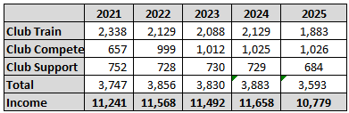
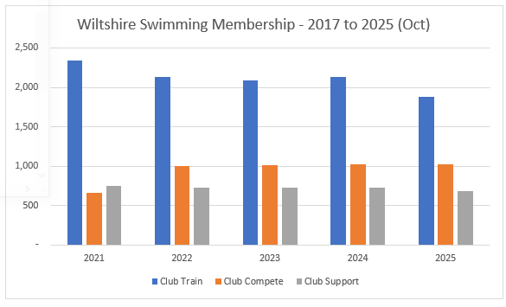
Monies collected so far from ASA total £10,779 [6 payments received in 2025], agreeing to the Swim England Communications.

INCOME / EXPENSES – Year to 31 Aug 2025
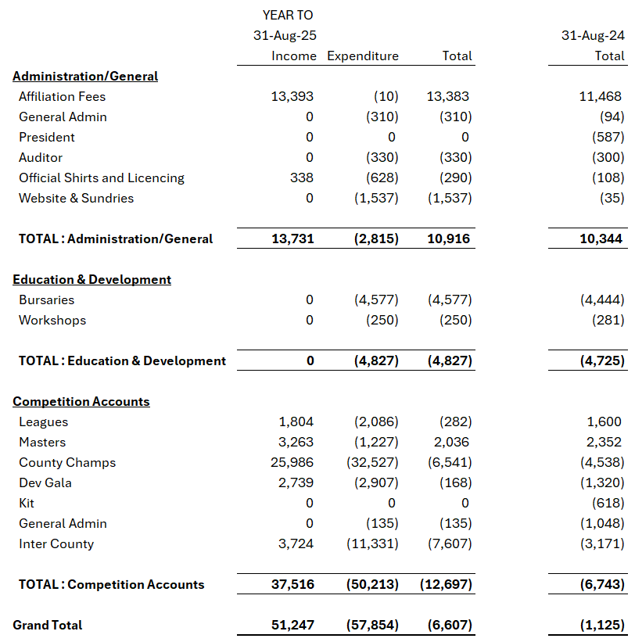

Included within the above affiliation fees are £600 relating to a bursary receipt, and £1,000 in trading income. The membership element is therefore £11,793. It should be noted that Swim England’s year is calendar based, whereas our year runs 1 Sep to 31 Aug. It makes interpreting swim England receipts somewhat confusing as some of the receipts shown in the 2024 year for Swim England are in the above table, and some in the 2025 column are not shown as they are received after the end of the reporting year.

The above report is based on the data set submitted to Orange Stripe for Verification and so is presented on an accrual’s basis, in line with statutory format.

This means that I have adjusted for monies owed to Wiltshire (Debtors), monies owed by Wiltshire (Creditors), Changes in stock holdings (Medals/Trophies) etc.

BALANCE SHEET AS AT 31 AUG 2025
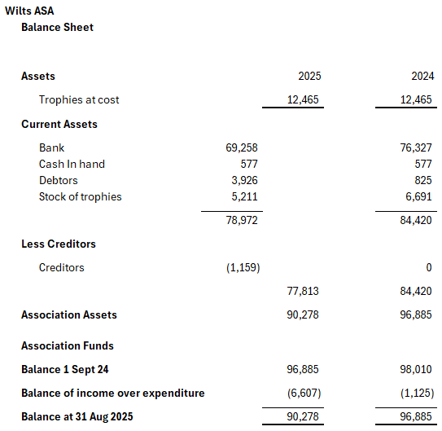

The balance sheet shows the cash in the year has depleted, by approx. £7k, however you will notice that the debtors’ figure has risen by almost £4k which represents clubs that had not paid for their entries into the Wiltshire League 2025, nor the Counties 2025 events. This is something that has been discussed at Financial Executive meetings, the outcome of which is the meet organisers will be working more closely with the treasurer to ensure that payments are made with entry for all events going forward. In future years therefore this number is expected to reduce.

CASH ON HAND DURING THE PERIOD
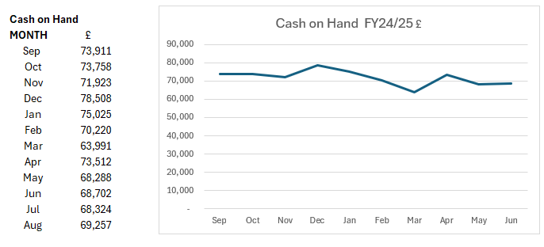
Total outflow in FY24/25 was £7,070.

OTHER MATTERS
This is my first full financial year as treasurer and there are a number of things that I am working on to get a greater understanding of, or to tidy up as we move into the new financial year.
- We have a large number of Trophies held on the books. My understanding is that these were last professionally valued by Deacons of Swindon at some point in the 1980s so the value shown may be substantially different today. Gold and precious metals are exponentially higher in value today that at any point, so I have asked for a catalogue of these trophies to be done, and where relevant an up-to-date valuation carried out. Once we have ascertained the value then we can discuss further the options of what to do with the trophies. Considerations being (but not limited to), showing in a trophy cabinet, putting back into supply, selling. There is clearly a large amount of history tied up in these, but we should be open to a discussion on how we best utilise these assets. They reside at the moment in a loft, and have been there for a little while.

- Cash in hand monies. This existed previously to provide ad hoc petty cash and a float to assist with door entry change for spectator allowed events. The modern approach which has been in place now for 2 years has been to use the sum up card machine. lent to Wiltshire by Tigersharks. Monies are simply passed through from club to county and no profit is made by Tigersharks on the transaction. This has been very successful and goes hand in hand with the cafes that are often on site also only operating on a non cash basis so people are used to using their cards for these micro transactions. We have discussed and agreed that during 2025/2026, the cash float will be paid back into funds and no further petty cash floats will be held.

- Trophy Stocks. As we start to look at the plans for 2025/2026 we will be putting a budget in place for medals and trophies, we have historically always purchased from one gentleman who is now of a retirement age, and we do not know how much longer he will be able to supply Wiltshire with its medals. We will therefore be encouraging that when we hold events we start to think about ordering in for the event itself and not stockpiling medals which is both burdensome and costly to do. I would welcome data to enable me to help plan out when we should next be thinking about ordering medals. Ideally I am looking for the number of medals utilised at each of the events listed below. Stocks on hand at the end of August 2025 were:
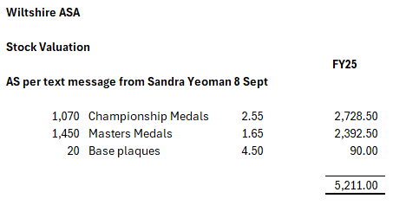
AND FINALLY…

I am delighted that following an intensive period of communications between myself and all of the club treasurers, all outstanding monies for 2025 events (shown as debtors in this report), have now been collected. I thank the clubs for working with me to resolve and for doing so in a speedy manner.

A breakdown of bursaries is shown below, it should be noted that only 6 clubs claimed for bursary support in the year. Help and guidance are available for clubs to ask for support, and I recommend that they reach out if they are unsure.

Bursaries by club

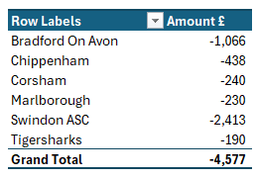

Appendix D
Wiltshire Swimming Masters Report

Wiltshire Masters competition; Final Block [3], Marlborough College, 27/9
Back again to 2024/block 2 2025 numbers (of swimmers) in the 70s after the brief euphoric 90+ attendance in Block 1 at Trowbridge. The reason for this spike in March (or drop off later in the year) is yet to be established

2025 roll of honour
Team: Tigersharks

Head Cup: Chippenham

Individual points awards:

- O/M 40-: Tyler Checchia (Tigersharks)
- F40-: Aimee Masters (Tigersharks)
- O/M 40+: Nick Hudson (Tigersharks)
- F40+: Vicky Williams (BoA); trophy for this is still to be located!

Regional Masters, Millfield 12 Oct
Fairly sparse turnout, as usual, on the whole, with a particularly low turnout for Wiltshire (8 swimmers, with another 2 entered, but withdrawn)

Swim England National Masters, Sheffield 24-26 Oct
More numerous turnout from Wiltshire than for the regionals, with Tigersharks sending a strong team, with single representation also from Warminster, Corsham, Melksham and Swindon Dolphin (noting also [dual-registered] swimmers from Swindon ASC, BoA representing Tigersharks)

Medals
Gold | Jon Audis (Tigersharks: 50m, 100m, 200m Back)  Jane Snedden (Warminster: 200m Back)  Aimee Masters (Tigersharks: 200m Back)
Silver | Stuart Gibbs (Tigersharks: 1500m Free, 200m IM)  Tigersharks: Open/Male 200+ 4x100 Medley Relay  Sarah Lock (Tigersharks: 100m Back)  Jane Snedden (100m Back)  Michelle Reid (Tigersharks: 200m Fly)
Bronze | Rebecca Smith (Tigersharks: 50m, 100m, 200m Free; 50m back)  Aimee Masters (50m Back)  Jane Snedden (50m Back)  Stuart Gibbs (800m Free)

Inter-county Masters, Millfield 9 Nov
Ink still drying on this one … A very creditable 3rd again from Wiltshire in the Regional gala, maintaining our position from the last few years. Still awaiting the National Results, to see where we placed overall.

Big thanks to Stuart Gibbs for organization and management of the team, and to officials (Andy Ryczanowksi, Dave Jones), and of course well done to the swimmers.

Subcommittee
Meeting planned for next Monday (17th November). Mainly to discuss 2026 Wiltshire events and subcommittee

More 2026 Dates
SWR Masters Sun 11th October, Millfield
Inter-counties has been shifted back a week from normal/originally advertised, to Sun 15th November.

Appendix E

Wiltshire Para Report November 2025

Para swimmer results from over the summer:

Ella, Swindon ASC - English Summer Nationals – Qualified for 100 fly, 200 IM, 50 free, 100 free, 100 back. Qualified for 4 out of 5 finals, finished 5th in 100 fly.
British Champs – qualified for 100 brs, made the final and finished 10th. Ella was racing against 18 other para swimmers in the multi class event, 13 of those swimmers were Team GB para swimmers.

Matthew, Swindon ASC - Matthew was classified as S14 over summer and in his first competition of the season qualified for 100 breast and 100 back at Winter Regionals.

Holly, Swindon ASC - Holly recently attended the European Downs Championships. Individual bronze medals in 50 breast, 200 breast, 200 fly and 100 fly. Team gold in woman’s 4 x50 medley relay and a new T21 world record, and 4 x 100 medal relays. Team silver mixed 4 x 100 medley relay.

Dorian, Trowbridge - Dorian also attended the European Downs Championships and came 10th in 400 free, 6th in 800 free, bronze 1500 free, team silver 4 x 100 free relay, team gold 4 x 50 free relay.

If I have missed any other Wiltshire para swimmers, then I apologise. I often have to search club’s social media to follow our swimmer’s achievements. I am more than happy for Club’s to send me regular updates as to our para swimmers, especially any swimmers being classified.

Region:

There hasn’t been a recent regional para committee meeting. However, I have voiced my opinion several times with region and the regional para coach that the meetings are held during the school day which as a school teacher I am unable to attend.

There has been some discussion on the regional what’s app groups asking whether clubs can be asked to consider including para events in their L3 licensed meets as it can be quite demoralising for our para swimmers when competing against able bodied swimmers in age groups to be way behind them. I don’t know if its possible to ask our Wilts clubs to think about including para events? I’m sure Leslie will know more about this.

County:

Thank you, Andy, for taking the time to meet with Dean and I and discuss all things para! It is great to hear that our classified para swimmers will be able to compete at Counties in the events for their classification that they have a time for on rankings. Thank you.

We did also discuss how to potentially increase the number of disabled/ para swimmers entering the Development Meet.

Awards:

Good luck to Andy, nominated for Technical Official of the Year in the Swim England Nationals Awards. The ceremony will be held on the 29th November – fingers crossed.

Congratulations to Kerry Rutherford who is a finalist in the UK Coaching Awards in the Young Coach category. The ceremony will be held on 4th December – fingers crossed

