 | WILTSHIRE SWIMMING  (Wilts County ASA Founded 1907)  Affiliated to Swim England South West Region  President: Rebecca Smith - Executive.
MINUTES OF MANAGEMENT MEETING
Tuesday 1 April 2025 – 19:00 held by Zoom.

- Welcome and Apologies
  - Attending: Andrew Ryczanowski, Andrea Christmas, Chris Selby, Diane Lee, Dennis Yeoman, Karl Mutton, Konrad Adams, Michele Greenan, Rebecca Smith, Rob Hart, Sandra Yeoman.

  - Apologies: Clair Murphy, David Jones, Geoff Pearce, Lesley Leffers, Melanie Sweetman, Paul Robbins, Paula Rutherford.

- Minutes of last meeting - 23 October 2024
  - The minutes from the previous meeting were distributed along with the agenda for all attendees to review. These minutes were accepted as an accurate representation of that meeting and were approved by all attendees.

  - SY highlighted an inconsistency in the minute headings across all committee documents regarding the current President. The heading should read "Rebecca Smith – Executive" rather than including her club affiliation, as she was appointed to the position by the executive committee. AR assured that this information would be communicated to all committees and he would review future minutes to ensure uniformity.

- Sectional Committee Meetings – All Minutes are available on the County Website.

  - Competition & League Meeting - 22 October 2024 – Minutes were reviewed and accepted. Points to note were highlighted:
    - County Championships for 2025.
    - Nominations for County AGM Awards
    - Intercounty Competition in Sheffield
    - County Development meet requirements for 2025
    - Wiltshire League was successfully completed in 2024 and will carry on in 2025 with a proposal for dates for 2025.
    - Cost of coach passes for open meets. This is not an issue in Wiltshire, but it is down to individual clubs and what they want to charge for their open meet packages. There is very little the County and Region can do.

  - Swimming Officials Panel – 9 January 2025 – Minutes were reviewed and accepted. Points to note were highlighted:
    - Championship preparations
    - Officials Training
    - Appointment of officials to support county teams

  - Education & Development Meeting – 23 January 2025 – Minutes were reviewed and accepted. Points to note were highlighted:
    - Review of County Funding Policy – working party set up.
    - New Land based coaching course available.
    - Review of Committee Aims and objectives.
    - Young Volunteer programme update.
    - Bursaries awarded.

  - Education & Development Meeting – 3 March 2025 – Minutes were reviewed and accepted. Points to note were highlighted:
    - New Funding Policy agreed.
    - WASPs potential funding for Safeguarding course

  - Event Team – 3 March 2025 - These minutes are to be discussed at the Swimming committee’s meeting being held later in the month. It is worth noting a lot of learnings came out as a result of the County using Bath for the Championship competition.

  - Coaches Meeting – 25 March 2025 – Minutes for this meeting are still being prepared and will be held over until the next meeting.

  - Swimming Officials Panel – 27 March 2025 – Minutes for this meeting are still being prepared and will be held over until the next meeting.

  - Masters Meeting – 9 December 2024 - KA highlighted a Masters Meeting was held on 9 December 2024 but was not listed on the agenda. AR apologies for the oversight and said they would be made available via the website. KA said he would cover the points from this meeting within his report below.

- Swim England Southwest Region Report – DL gave the following report:
  - 15 January was the last Board meeting which had followed the very successful Regional Workshops weekend and the 4 & 5 January 2025.

  - As of 1 April 2025 the fee for regional safeguarding course is being raised to £15, which is still cheaper than Swim England.

  - A County day is being arranged for the 8 June 2025, with Andy Salmon, CEO of Swim England being the main speaker. This session will also be opened up to Club Chairs to attend.

  - 21 September 2025 has been set for the Volunteers Awards Presentation.

  - Next years Regional Workshops weekend has been scheduled for the 10th and 11th of January 2026.

  - This years Regional AGM has been moved from 26 March 2025 to 9 April 2025 due to a clash with a Swim England Event that will remove a large number of people who would normally attend the AGM.

  - The next Regional Board meeting is scheduled for the 15 April 2025.

  - DL informed the meeting the Region had produced a pop-up banner reminding everyone not to have mobile devices in changing areas. These banners will cost £35.99 each and can be purchased through the Region. After discussion it was proposed by DL, seconded by AR and passed unanimously to purchase 2 banners for the County.

  - SY questioned why the Region have selected the 10/11 January 2026 for their Workshop weekend when this is a direct clash with the start of the County Championships. After a discussion SY proposed the County should ask the Region to move the dated for the 2026 Regional Workshops to another date. This was seconded by MG and passed unanimously. Action: AR will email Chrissie Robinson to consider this request.

- Diversity, Inclusion, Safeguarding, Welfare and Governance – AR gave the following report:
  - Diversity – 31 March 2025 – Swim England has published a new action plan to highlight the long-term commitment it is taking to make its sport and activities more accessible, diverse and inclusive.

The national governing body’s Diversity and Inclusion Action Plan (DIAP) aligns with its recently launched new strategy, One Swim England, to tackle inequalities and remove barriers which currently prevent participation in swimming, diving, water polo and artistic swimming.

The plan includes objectives and actions which will be completed in the short, medium and long-term. As part of the organisation’s commitment to transparency, progress updates will be published in July and January each year.

Insight highlights that people from ethnically diverse communities, the LGBTQ+ community, disabled people and those with long-term health conditions and from lower socio-economic groups are under-represented within the aquatic community.

Mike Hawkes, Swim England Head of Diversity and Inclusion, said he was looking forward to seeing how the DIAP would drive the impact in the future and ensure that the foundations were in place to enable long-term change.

  - Safeguarding – Mobile Phones in Changing Rooms – The change in policy on the eve of the Bath leg of the County Champs was dealt with very well by the Events team and the Club Coaches. Well done all but this is to become second nature now. No active mobile devices in changing areas and if seen must be reported to those in charge and welfare Officers informed also.

Number of complaints has risen within the county, but most of turn out to be grievances.

All welfare and safeguarding complaints must be reported to the safeguarding team at Swim England.

  - Governance – All County Committee Members are required to sign a code of conduct for the County position. These will be sent out via email and acknowledgement by return is all that is required.

- Finance – KM was not present but send in his report (see appendix A):
  - Membership numbers have been constant over the last 3 year and currently stands at 3,883. This will deliver a membership fee income of £11,658.

  - The Cash Held in the Bank account is as follows. All balances shown are at end of month, the balance at the start of the new financial year (01 September) was £76,327. Cash spend since start of the financial year has been a net outflow of £12,336.

  - Cash in over the period totals £31,971, with the largest income lines being Entry fees and Spectator fees.

  - Expenses out of the same period total £40,828, with the largest single spend being that of pool hire, £16,312 followed by Trophies medals and certificates £8,680.

  - Included within in expenses and will perhaps be better described in future reports is hotel costs of £3.4k (Rotheram Sep 24), and £1.0k for the purchase of county clipboards as previously agreed.

  - SY pointed out the cost of Medals/ Trophies / Certificates is high because the factory that produced the metal plaques we use closed at short notice and it was decided to purchase a 3-year supply to give us a chance to find another supplier.

  - It was questioned at a recent County Event in Bath, why the charge for door entry was going to Tigersharks. However, it can be confirmed that all fees taken via “Sum-Up” are passed on without charge and sit in the bank account of Wiltshire. It maybe worth to consider adding a small sign stating that Wiltshire is using the “sum up” machine owned by Tigersharks or other such wording to make it clear at future events or to open up this provision to other clubs willing to help the county in a similar fashion.

- Education & Development – AC reported to the meeting the following:
  - The Education and Development committee have relooked at the bursary policy following feedback from clubs and County members. A proposal is being recommended to the meeting and is laid out in Appendix B. This proposal will re-instate a funding for teaching courses and move from a percentage value to a cash value for all courses. For example, a level 2 (Club) coaching course will be granted a bursary of £220 whereas a level 2 (Teacher) teaching course will get £140. Clubs are also reminded that by applying through the Club’s account Swim England/IOS will discount the course by 40% as well. The county is encouraging clubs with the financial incentive to get as many volunteers qualified to support their club’s needs.

  - Currently there are not coaching courses set up within the county but Stacey at the regional office is willing to help clubs find courses or set them up if sufficient demand can be seen.

  - SY expressed her concern the proposal disadvantaged teaching courses as se feels that good teachers’ skills are needed for the individual to move on to coaching swimming. By moving this way, she felt that poor quality coaches would result. After a lengthy discussion the proposal from the Ed & Dev committee was put forward as it was with a review of this after a year. The proposal was passed by majority vote.

  - The Ed & Dev committee are currently looking at the aims and objectives they are to working towards.

  - The Young Volunteer programme for 2024/25 has wrapped up and all participants have received their polo shirts. They have also been encouraged to take the timekeeper’s course.

  - No additional bursaries have been paid out since last meeting.

  - Wasp (Wiltshire and Swindon (sports) Partnership have approached the county with funding for safeguarding courses. It has been agreed the county will invoice WASPs for all Safeguarding bursaries that are paid out. This is on trial for the next year.

  - Due to a demand from the Coaches Committee, Ed & Dev have been working with the Regional Office and Rich Smith to put on an additional Team Manager 1 course. At present we have 35 volunteers across 9 clubs wanting a course. So, for the time being please watch this space.

- Swimming – SY gave a brief report:
  - County Championships went very well, especially as we took the big step to use Bath University pool for the very first time. A lot was learnt over this weekend for a venue that has not held such an event in a very longtime. A big thank you to all that helped deliver this event and all the events of the Championships and Age groups.
  - The Development meet is scheduled in Salisbury for 18 May 2025. Details are out with clubs and entry window is currently open. We will know attendance after the 26 April 2025 closing date. So far things are looking encouraging.

  - CDPP (Swimming Committee) – SY is looking for a date over the next few weeks to hold a committee meet, possible dates could be 15 or 29 April 2025 and she will be canvassing committee members in the next day or two. DL stated she could not attend on the 15 April as this is the date of the Regional Board Meeting. SY feel this year it should be easier as we’ve had a good plan this time round and it will be the same again with a few minor improvements. Swim England have not made any changes for 2026 as they are still in the review stage.

  - Regional Swimming Committee – The January meeting was very short and had very little to cover. The next meeting is 2 April 2025, and this should have more content to discuss.

  - Development Pathway and Camp – ReS gave the following report:
    - 3 speakers have now been booked for the on-line workshops with a big thank you to Di Elliott who came back with names. The sessions are booked for Monday 28 April 2025, Wednesday 14 May 2025 and Thursday 6 June 2025. This mean they will all be delivered before the final camp takes place on the 15 June 2025 at Calne Leisure Centre.
    - It is hoped these workshops could be opened to more than those swimmers attending the camp and to more coaches as well.
    - ReS stated that the camp was still short of helpers. More coaches and team mangers are needed to ensure the camp can run well. ReS passed on an idea from Duncan Hibbard (Bradford on Avon) for people who have just completed coaching Level 1 (Assistant Coach) could be approached as they have been partly funded by the county to help. The meeting felt this was a great idea and that DH and LL should work together to approach those who have recently completed.

  - Wiltshire League – Details have been sent to clubs regarding this year’s competition with the final set to be held in Bath on the 14 September 2025. Conditions for this final are currently being worked on with the intention for the final to be licenced, plans are to have two rounds complete in the period April/May and June/July. However, as long as two rounds are complete by the end of July 2025 it doesn’t matter when they are raced. It will be down to the 4 groups of clubs to decide.

  - Local Gala – Devizes, Durrington and Westbury recently held a local gala with the aim to give their swimmers a change to swim a league style event and for this to be a fun occasion. To encourage this style of event the County agreed to pay for the water time. Feeback from the clubs was very positive and it went down well with the swimmers.

  - Licencing - It has been flagged that certain times of the year there is a big demand from clubs to hold licenced Club Championships and open meets. This is putting a big strain on Officials as some clubs cannot run meets without using officials from other clubs. SY & LL would like to restrict this but have not been able to come up with any suggestions yet. SY asked if they could have some more time to look at this. The meeting agreed.

DL asked for clarification on Level 4 costs and LL4 costs in relation to Clubs running dual club championships. This is a difference of £25 fee for the year verses 20p fee per swim in the event. Action: AR to Clarify this with LL and to feedback to DL

- Water Polo – CS gave the following report:
  - League season is well underway and Bradford on Avon (BOA) are doing very well at present. Swindon have only played one game so far, a good 12 – 12 drawn game with BOA.

  - Cup competition we now have only one Wiltshire club left in after Swindon beat BOA 11 – 10 to reach the semi-final stage.

  - The questionnaire was disappointing as only 6 clubs returned it. The main reasons for not supporting water polo are lack of water time and coaches. However, the clubs would be prepared to send swimmers for taster sessions. CS will need to do some more work on this now to set up some taster sessions.

  - ReS suggested that at levels 8, 9 & 10 learn to swim providers should not only focus on competitive swimming but to look at water polo, artistic swimming and diving as alternatives. CS and ReS will look at persuading local providers to do this as a route into these disciplines.

- Artistic Swimming – CM was not present, and no report was submitted.

- Diving - MS was not present, and no report was submitted.

- Masters – KA gave the following report:
  - Round 1 of the Wiltshire Masters competition took place at Trowbridge recently, with around 90 swimmers taking part. This is up from the 70 we had last year. Also, we had more entries in the senior age groups as well as the older groups. Calne Alpha 4 and Tidworth sent swimmers for the first time in a while.

  - The next round has finally been settled for the 17 May 2025 at the Link Centre. DL stated that her club provides the equipment for this at the Link but had only just become aware of this and she is still working on it. ReS asked if it is possible to have a list of contacts for equipment at various pools so that these people could be engaged sooner. Action: County to Set up this list and provide it to the Masters’ committee.

  - The Committee are hoping to fix dates for regular weekends each year as this year had issues after agreeing dates because Swim England then published their dates for the British Masters which then clashed with our June date. SY stated that she has provided dates for 2026 to ReS.

  - Other dates for the future are:
    - 27 September 2025 – Round 3 of Wiltshire Masters at Marlborough College
    - 12 October 2025 – Regional Masters at Millfield
    - 9 November 2025 – Inter Counties at Millfield – Stuart Gibbs is heading the selection team for this.

  - Contact details on the Swim England site was wrong but has now been updated to KA, and Region still has Dan Pickup as contact and this should be KA. County to contact region to correct.

  - Outside of normal competition we are looking to provide other activities, such as a county training day. The County will provide support if it is needed.

- Para-Swimming – PR could not attend but reported the following:
  - Since the start of this season, we have had two more swimmers classified. Nati (S8) at Swindon Dolphin and Eloise (S8, SB7) at Swindon ASC. Both have been enjoying competing as classified para swimmers. Eloise competed in her first Wilts Counties which was a great achievement for her. Nati chose to compete in Somerset Counties with her friends at Team Bath. We had three classified para swimmers competing in Counties – Ella, Holly and Eloise all from Swindon ASC. The swimmers are now focussing on Regionals and Para Nationals. Thank you to the events team for facilitating our para swimmers at Counties. I really appreciate your support.

  - Swindon ASC Para Squad have been using the new radio headsets purchased by the County in training. These have been very beneficial to all our swimmers but particularly to a swimmer who is completely blind. Tegan struggles to know where she is in the lane so frequently feels for the wall which impedes on her stroke and technique. Using the headsets, I can constantly keep her up to date with where she is swimming which has helped her develop her confidence, swim in a straight line (this is very difficult when you can’t see!) and improve her strokes.

  - Swindon ASC Para Squad also recently had a visit from Paralympian Stephanie Millward MBE. Stephanie delivered a great presentation about her swimming career and the benefit of having a positive mindset. The swimmers were able to wear her gold medal and hold an Olympic torch. Stephanie then coached the poolside session. This was a great experience for the swimmers which was funded by the charity Artic One Foundation. Artic One awards grants to para-athletes across a range of sporting disciplines from grass roots to Paralympics. The charity has previously awarded grants to three para swimmers in the county. If anyone would like to know more about the charity, please let me know.

  - Within the county, PR is aware of two swimmers who are currently going through the S14 classification process. Several swimmers at Swindon ASC are approaching the standard required to apply for classification. Hopefully over the next year we will have more classified para swimmers in the County.

  - PR would be very grateful if Clubs that have any swimmers with disabilities or swimmers that are already classified could let me know please so that I can keep myself informed of their development and progress and ensure that they receive details of training days and competitions. If I can be of assistance to any Clubs that need any advice re supporting swimmers with disabilities, then please let me know - I am not an expert but am happy to help! I do have a Facebook group called Swindon Disability Swimming Community and Friends which I am happy for the details to be shared with any swimmers, parents, coaches, etc that may wish to join.

  - Adam Clarkson, regional para lead and coach has advised that they are working on a new para welcome pack. This is a great idea as the para classification pathway can be quite complex depending on the swimmer’s disability.

  - They are also working on a new para learn to swim programme and criteria. Again, this will be beneficial for our para swimmers as we often must adapt the criteria to meet individual needs, i.e. my swimmers with hemi cerebral palsy are never going to be able to perform simultaneous arm or leg movement.

  - Region has also pulled together a para data base of the 105 classified para swimmers and those awaiting classification. As previously requested, if clubs can let me know of any para and disabled swimmers that they have in their clubs then I can ensure that they are included on the database.

  - Upcoming training – 19th April at Taunton School and 12th July at Riverside Centre, Exeter.

- Open Water Swimming -
  - We are without a secretary and/or committee members. We are looking for volunteers, please contact the Executive if you are interested.

  - The Regional competition is being held at the Cotswold Water Parks, Lake 86 together with West Midlands, East Midlands and Swim Wales on Sunday 22 June 2025.

  - ReS asked if County medals could be awarded at this event as it is local and a big number of Wiltshire swimmers would be involved. It was agreed to do this, and ReS will coordinate it as she is partaking.

- Any Other Business –
  - There was no other business.

- Date of Next Meeting – All meetings will start at 7:00pm except for AGM which is a 9:15 am for a 9:30am Start.
  - Wednesday 21 May 2025 – Management Executive
  - Tuesday 8 July 2025 – Full Executive – All Clubs
  - Monday 8 September 2025 – Management Executive
  - Tuesday 21 October2025 – Management Executive
  - Saturday 29 November 2025 – AGM
  - Wednesday 17th December 2025 – Management Executive TBC

Meeting Finished at 20:45

Appendix A – Financial Report from Treasurer

Summary Financial Report – 1 Sep 2024 to 31 Mar 2025
SWIM ENGLAND MEMBERSHIP
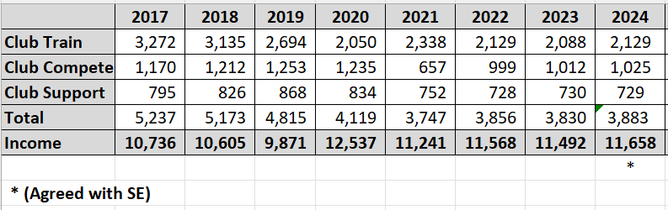
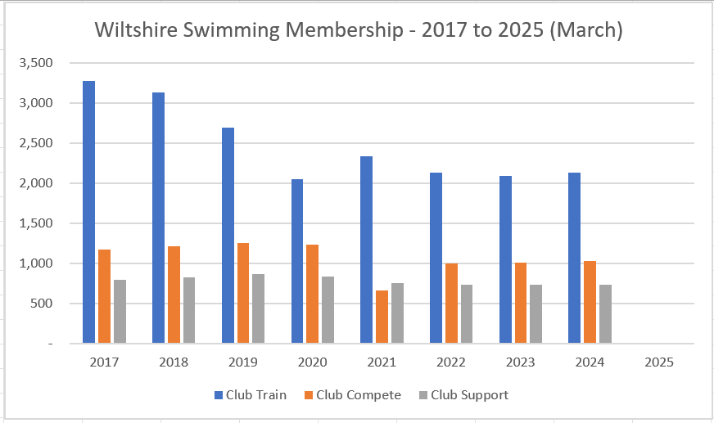
There is no data yet available for 2025, this will be communicated to us during April 2025.

INCOME / EXPENSES

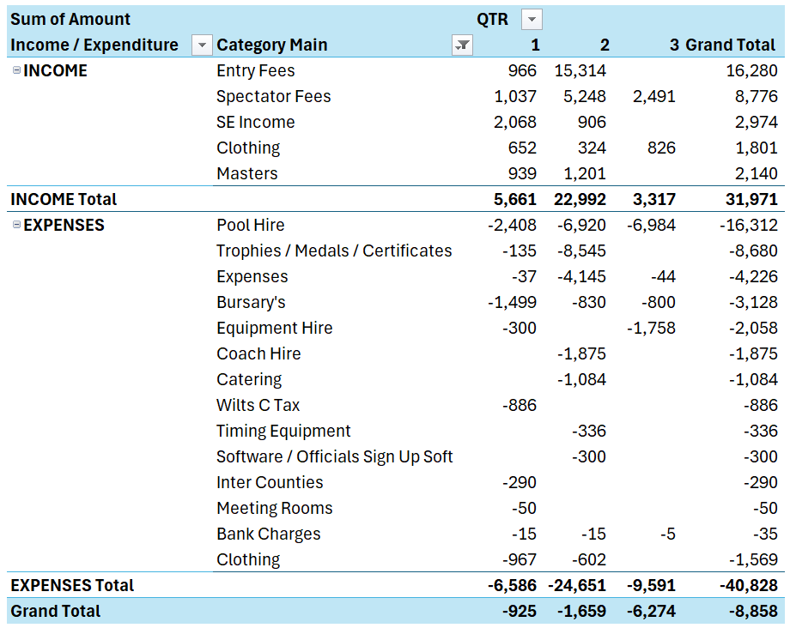
Above table is prepared on a cash basis and covers the period 01 September to 31 March 2025. For the purposes of clarity, the following is denoted:

Q1 = Quarter 1 (September, October, November 2024)
Q2 = Quarter 2 (December 2024, January, February 2025)
Q3 = Quarter 3 (March 2025)

I am using this as the basis of both reporting in this group and for the statutory accounts, which I am pleased to note are now with Orange Stripe and waiting for comment and review. Once this is complete the accounts will be circulated.

The Cash Held in the Bank account is as follows. All balances shown are at end of month, the balance at the start of the new financial year (01 September) was £76,327.

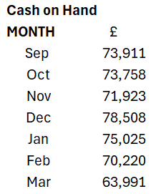

Cash spend since start of the financial year has been a net outflow of £12,336 Cash in over the period totals £31,971, with the largest income lines being Entry fees and Spectator fees.
Expenses out of the same period total £40,828, with the largest single spend being that of pool hire, £16,312 followed by Trophies medals and certificates £8,680. Included within in expenses and will perhaps be better described in future reports is hotel costs of £3.4k (Rotheram Sep 24), and £1.0k for the purchase of county clipboards as previously agreed.

OTHER MATTERS

Carrying forward the query from the last meeting where I raised an insurance query question. Given that our costs in this area over this period have totalled over £8k I would like to be sure that we do have coverage in place for the storing of them. Please can this be confirmed?

We will be expecting our first receipt of Swim England fees in early April, in prior years this has been approximately £9k so will put the bank balance back up near levels seen at the start of the period.

It was questioned at a recent County Event in Bath, why the charge for door entry was going to Tigersharks, however I can also confirm that all fees taken via SumUp are passed on without charge and sit in the bank account of Wiltshire. Do we wish to consider adding a small sign stating that Wiltshire is using the “sum up” machine owned by Tigersharks or other such wording to make it clear.

Appendix B – Education & Development

Education and Development Committee -Notes from sub-meeting to discuss funding.
Held on 4th February 2025

Present - A Ryczanowski, K Mutton, A Christmas.

At the Ed & Dev committee meeting on 23rd January it was decided as Karl/treasurer was unable to attend the meeting that AR, AC and KM should meet to bring Karl up to speed with the recommendations of the committee and to discuss future funding levels.

It was very much the feeling of the meeting that giving bursaries to clubs was an even-handed way of supporting the clubs.

The following proposals were made; these will be taken to the full Ed & Dev meeting on 3rd March.

- We would move away calculating bursaries from the percentage of the course cost and move to a set amount per qualification, these were proposed as follows-

- Level 1 Coach - £125
- Level 2 Coach - £220
- Level 3 Coach - £700
- Level 1 Teacher - £80
- Level 2 Teacher - £140
- Level 1/2 Teacher - £190
- Land Based Coach - £100
- CPD’s to remain at £10 pp per CPD.

The above would come into effect on 1st April 2025.
This would be reviewed in March 2026.

Lesley will hold any claims received between now and 1st April so that claimants receive the higher amount.

All other criteria relating to bursary and funding claims would remain as set out in the Funding Guidance Document and on the Claim Forms.

