 | WILTSHIRE SWIMMING  (Wilts County ASA Founded 1907)  Affiliated to Swim England South West Region  President: Rebecca Smith - Executive.
MINUTES OF FULL EXECUTIVE MEETING
Tuesday 8 July 2025 – 19:00 held by Zoom

- Welcome and Apologies
  - Attending: Andrew Ryczanowski – Wiltshire Chair, Lesley Leffers – Wiltshire Coaches Secretary, Andrea Christmas – Wiltshire Ed & Dev Secretary, Sandra Yeoman – Wiltshire Swimming/CDPP Secretary, Diane Lee – Wiltshire League Secretary, Scott Garrett – Calne Alpha 4 Head Coach, Tim Sadler – Salisbury Stingrays Head Coach, Matt Cruse – Chippenham Head Coach, , Zahid Mahmood – Corsham Head Coach, Tessa Brennan – BoA Coach, Paul Honeyman – Royal WB Head Coach, Dom Keogh – Marlborough Penguins Head Coach, Duncan Hibbard – BoA Vice Chair, Erica Hodgson – Marlborough Penguins, Natasha Falkner – Salisbury Stingrays, Jaan Nellis – Trowbridge ASC, Karl Mutton – Wiltshire Treasurer, Rebecca Smith – Wiltshire President & Competition Secretary. Rob Hart – Wiltshire League, Lynne Eddy – Calne Alpha Artistic Swimming, Konrad Adams – Wiltshire Master Secretary, Allan Mccouig – Malmesbury, Mark Whiting – Malmsbury, Andi Holbrook – Tigersharks Chair, Geoff Pearce – SWR Treasurer & Wiltshire President Elect

  - Apologies: Chris Selby - Water Polo Secretary, Dave Jones - Officials Panel Secretary, Warminster SC, Devizes SC, Michele Greenan – Wiltshire Secretary, Paul Robbins – SWR Officials Representative, Swindon Dolphin ASC, Dennis Yeoman – Wiltshire Emergency Committee Member. Claire Murphy – Calne Alpha Artistic Swimming.

- Minutes of last meeting – 1 April 2025
  - The minutes from the previous meeting were distributed along with the agenda for all attendees to review. These minutes were accepted as an accurate representation of that meeting and were approved by all attendees.

- Sectional Committee Meetings – All Minutes are available on the County Website.

  - Wiltshire Coaches Meeting – 25 March 2025 – Minutes were reviewed and accepted. Points to note were highlighted:
    - County Championships for 2025.
    - Development Camp – Still requiring coaching support
    - Briefing on the Wiltshire League
    - County Development meet to be held in Salisbury on 18 May 2025
    - Encouragement for coaches to try on-line CPD courses, bursary support given.
    - To many clubs running meets at certain times of the year causing issues with officials and licencing concerns.
    - Lesley Leffers re-appointed Wiltshire Coaches Secretary for another year.
    - Richard Smith re-appointed as Regional Coaches Representative for Wiltshire.

  - Swimming Officials Panel – 26 March 2025 – Minutes were reviewed and accepted. Points to note were highlighted:
    - Confirmation of Rohaise Des Voeux as County Official to the Inter County event in Sheffield.
    - Mark Kelly of Warminster ASC passed his referee assessment
    - David Jones re-appointed as Secretary to the Officials Panel for another year.
    - Paul Robbins re-appointed as regional representative for Wiltshire.

  - Swimming/CDPP Meeting – 6 May 2025 – Minutes were reviewed and accepted. Points to note were highlighted:
    - County Development Meet to be held on 18 May 2025 discussed and will happen in Salisbury. Conflicting information was sent out which cause issues, but all has now been resolved.
    - Selection policy for County Representation was discussed and a revised policy to be produced.
    - County consideration times for 2026 approved and will be active for the Development meet.

  - Swimming/CDPP Meeting – 11 June 2025 – Minutes were reviewed and accepted. Points to note were highlighted:
    - A review of the Development meet was undertaken, and a lot of learnings were being taken away.
    - An additional Coaches meeting was requested to understand what coaches would like the Development Meet to look like and who should be allowed to compete.
    - County Calendar was discussed.
    - Programme for the 2026 County Championships was provisional set.
    - Terms and conditions for County meets to be reviewed and updated for 2026. Paul Robbins added to the vetting process.
  - Education & Development Meeting – 9 June 2025 – Minutes were reviewed and accepted. Points to note were highlighted:
    - Wiltshire And Swindon Sports Active Partnerships (WASPs) to fund County Clubs for all Safeguarding courses by re-imbursing fees paid.
    - New Bursary and Funding Policy approved. Also, CPD and Safeguarding bursaries to rise to £15 as region has put fees up to this amount.
    - Committee aims and objectives still in progress.
    - £715 of bursaries and £630 CPD fees have been paid out over the last 3 months.

- Swim England Southwest Region Report – DL gave the following report:
  - There has been a recent South West Region AGM and a Swim England AGM.

  - The SWR is Recruiting for a new Chair, Vice Chair, Independent Safeguarding Officer & and an Inclusivity & Diversity Officer.

  - The SWR Volunteer Awards Evening will be held on 21st September 2025 – Nominations still open.

  - DL asked where the County stood with regards to the Pop-up Banners for Mobile Devices not allowed in Changing Area. Action: AR to contact the SWR office to sort out purchase to at least two banners.

- Club Feedback –
  - Clubs were posed the following questions by the Management Executive
    - What do Clubs want the county to do for them
    - What events do the clubs want the County to run.
    - Anything else you would like the county to consider.

  - Lynne Eddy – Calne Alpha Artistic Swimming would like to see wider inclusivity of Artistic Swimming in Wiltshire. They are currently the only club in Wiltshire offering Artistic Swimming to swimmers.

AR outlined that earlier in the year Water Polo were asked the same thing, and they put out a questionnaire to all Wiltshire clubs trying to drum up interest. While the response was not great, CS is in the process of setting up taster sessions for those who were interested. AR suggested Lynne may choose to do the same by setting up taster events. The following clubs expressed interest in these taster sessions; BoA, Corsham, Tigersharks, Royal Wootton Bassett Otters & Salisbury.

SY mentioned that in years gone by Wiltshire had monthly sessions of Water Polo and Artistic Swimming for interested swimmers to come along and try. Could Wiltshire think about doing that again?

LE also asked if there was any way of keeping in touch with officials once swimmers have left or moved on? This would help with the shortages of volunteers for putting on events. This will be explored.

  - Andi Holbrook – Tigersharks – Richard Smith (Head Coach Tigersharks) asked him to request the County should return to County run CPD Courses, particularly for L1 & L2 Coaches.

AR highlighted the Swim England CPD courses were excellent starting point and we should be considering these first. Also, CPD from SE are accredited and added to the Coaches profile. Bursary can be claimed for these CPD courses to offset the expense. The County would look at setting up CPD courses if there is sufficient demand and support shown, but the clubs will need to note these courses would not be accredited.

AH was also asked to bring up the need of support from coaches for the Development Camps. This was discussed in Rebecca Smiths report later in the evening.

  - Jaan Nellis – Trowbridge ASC – They would like to see a much better co-ordinated effort for getting newly qualified Officials within the club and progressing the current officials to higher qualifications.

AR explained getting and retaining volunteers is a big issue throughout swimming. Since the pandemic it has been increasingly difficult for clubs to recruit volunteers and even when they do the turnover is massive. Keeping hold of officials is particularly hard as those who qualify at JL1 very often are only within the sport for a year or two, it tends to be a constant conveyor belt of recruiting, and training. LL offered that currently the County only has 19 trainees for JL1 out of all the clubs in the county. This is well below all other counties in the SWR.

  - Matt Cruse – Chippenham ASC – The swimmers thoroughly enjoyed the Development meet and the club felt the level of events and the one-day meet were correct for the level of their swimmers. The swimmers could choose just the shorter events or try longer distances if they were capable. He thanked the events team for their efforts.

  - Duncan Hibbard – BoA – He feels we must ensure Coaches are aware the Development Camps are also there for the development of Coaches more than the development so swimmers. This needs to be made clearly to those newly qualified coaches and to be promoted more for next year. He also said that BoA had been working very hard on getting parents to volunteer as Officials, and they are now able to cover their internal L4 meets without requiring help. Congratulations to them.

  - Dom Keogh – Marlborough Penguins Head Coach – Swimmers and Coaches really enjoyed the Relays at the County Events and wished for them to be retained and extended, if possible.

- Finance – KM gave the following summary of his report which can be seen in Appendix A.
  - KM commented on whether Covid has had a knock-on effect to our swimming numbers in the County. Numbers are down particularly in Club Train category. He also feels that because of Covid restricting parents at the time, many parents are still operating on a drop and leave basis so getting officials and volunteers is becoming more difficult.

  - Wiltshire has an overspend currently of £7,625. However, there are debtors of just over £4,000 and still some £2,448 to come in for League fees. This will bring Wiltshire to an equal balance or there abouts for the full year.

  - KM suggest due to the size of the County’s account that Wiltshire Swimming should consider the purchase of equipment, such a new Starter System that would work with all systems used throughout the county and clubs could hire if need be. This was discussed and further details would be required; also, other ideas should be sought for funding for the benefit of county clubs. This will be discussed more at the next Finance meeting.

  - For end of year reporting KM requires the approximate balance of all awards, medals, T- Shirts and any other stock items held. SY has agreed to get this to him in the next week or so but has stressed it would be approximate as we still have a Wiltshire Masters competition to fulfil.

- Education & Development – AC reported to the meeting the following:
  - AR explained the availability of funding provided to Clubs by Wiltshire and Swindon Sports Partnerships (WASPs) in addition to the funding offered by the county. All details can be found on the Wiltshire Website under Education & Development.

  - Bursary Funding for CPD Courses has been raised to £15.00 (was £10.00). This was due to Swim England South West Region raising the cost of Safeguarding course to £15. Again, all details can be found on the Wiltshire Website under Education & Development.

  - Various Bursary requests have been paid to several clubs/claimants. £710 on CPD and £815 for Coaching & Teaching courses.

  - A Bursary has been agreed to help BoA with the cost of a Senior Coach Qualification for Rebecca Smith of £750 which is 1/3 of the cost of the course. Congratulations to Rebecca on being accepted for this course.

  - It has been agreed that Bursary payments will trigger an email to all recipient of Coaching Bursaries. This email will invite them to take part at the next Development Camp. This was to continue to develop their coaching skills with other senior coaches and as a way of paying back the County for the financial support given to them and their clubs.

  - There is a L1 Assistant Coaching Course running in Sept/Oct at the Link centre. For details visit https://instituteofswimming.org/search?course=1751879332062x178641479396117740 At the time of minutes there are only 4 places available to book.

  - The SWR are running the following courses:
    - Team manager 2 – 14 September 2025
    - Safeguarding – 5 September 2025
    - Time to Listen – Runs Monthly
    - Team Manager 1 – Is now full – please contact Stacey Millett to register your interest in future courses.

  - The Young Volunteers Course is finished, but a few Wiltshire Clubs are yet to sign off their candidates with Jackie Hilliard at the SWR Office. Please can clubs complete the final process ASAP.

Regional Contacts are: Stacey Millett - stacey.millett@swimming.org; Jackie Hilliard - jackiehilleard@gmail.com

- Swimming
  - County Championships – SY updated on Wiltshire Championship and age groups possible date changes
    - Age Group 10-13 years Competition Day three – 24 Jan 2026 to 31 Jan 2026
    - Team Relays & 100m IM 14 years Plus - 25 Jan 2026 to 1 Feb 2026
    - 1500 Freestyle – 14 Feb 2026 to 17 Jan 2026
These possible changes will be confirmed ASAP.

Agreed date for extra Coaches Meeting of 21st July 2025 to discuss the Development Meet 2026.

  - Wiltshire League – Diane Lee & Rob Hart
DL apologised for the somewhat ad-hoc arrangement of this year’s Wiltshire League. She explained that this year with one Wiltshire event running into another it hasn’t been possible to deal with them as she would have liked. Diane & Rob thanked the club for their patience and help in facilitating the league galas. She reported that both Final Galas were now Licenced at Level 4 and will be held on the 14 September 2025, in Bath, and that the times will be able to be used towards Wiltshire 2026 Qualification.

LL Congratulated the League Committee on making the event work and said they had nothing to apologise for. As always, a great job has been done by the team. This was reiterated by AR and Allen M of Malmesbury.

  - Development Pathway – Rebecca Smith
The last day of the Development Camp ran successfully on 14 June 2025, despite a real shortage of assistant coaches. The swimmers really enjoyed both the Face-to-Face days and the online content days.

Coaching support is a big issue, and the County will try and encourage New Assistant Coaches (Level 1) and Newly Qualified Swimming Coaches (Level 2) to try and attend and support the County Development camps, it will also help in their own development. To encourage this an invite to the camps will be sent to all those who have had their qualifications funded via the County Bursary scheme.

Dates for 2026 will be notified to all clubs soon.

- Water Polo – CS was unable to attend due to a match in Cardiff but sent in his report:
  - County - Overall numbers are slowly increasing mainly within the Junior divisions of both Water Polo clubs in Wiltshire.

There are not enough numbers to compete as a county in both Seniors and Junior categories but with the steady increase it should only be a matter of time before we enter as a county independently but in the meantime will look to join forces with other counties where possible.

  - Bradford on Avon - Seniors are performing well in the league as we enter the final few games with a chance of promotion. The senior numbers are still looking low and actively looking for more seniors.

Junior ranks are doing well and regularly getting 10 to training and on occasions are getting over 15.

  - Swindon Dolphin - Seniors are performing well and doing well in the league (currently top - although having played more games).

Swindon are also through to the semi-final of the president's cup. Swindon will also be attending the Lyme Splash Tournament.

Swindon are also following a similar pattern to BOA in the junior section with consistent numbers of over 15. Swindon will be joining with Frome for the upcoming u17 tournament sending 6 players.

Swindon are on the lookout for funding for some shot clocks for their scoreboard.

Swindon have 3 people interested in the assistant Water Polo Coaching course.

- Artistic Swimming – Lynne Eddy – On Behalf of CM
  - Lynne is a coach at Calne Alpha Synchro Club which is currently the only club offering Artistic Swimming in Wiltshire presently. Numbers are steady with swimmers joining from racing clubs who are feeling a bit despondent with racing or not quite making the mark.

  - The club is competing very well and has recently won medals at a SWR Competition. Gradings continue and doing very well.

  - The club is financially stable currently. However, the club is experiencing the same issues as Swimming Clubs with getting volunteers for all roles, Officials, Coaching, Team Managing. There are also some problems with the SWR arranging the required courses to put the volunteers on.

- Diving - MS was not present, and no report was submitted.

- Masters – KA gave the following report:
  - The second round of the Wiltshire Masters ran well, although the numbers were slightly down. This may have been because of a late change of date. Round three is due to take place on 27th September at Marlborough College. KA advised KM that he was aware that he needed to pay the County the fees due for the second round and would do this ASAP.

  - The County had 23 swimmers representing them at the British Masters with many medallists from the swimmers. KA and ReS will compile a list of the medallists for AR to add to the website.

  - The same applies to the Wiltshire Masters at the recent SWR Open Water. Congratulations to them all.

  - The Masters have entered a team into the SWR Inter County event on 9th November 2025.

  - The Dates for the 2026 Masters Competitions are pencilled into the Wiltshire Calendar.

- Para-Swimming – PR submitted report post meeting.
  - There is not much to update but I did want to congratulate three of our para swimmers who recently attended the National Junior Para Meet in Coventry. It was Ella Williams (Swindon) last meet competing at a Junior, and she won gold in 200 breast stroke and bronze in 100 fly. Eloise Conway (Swindon) and Natalie Webb (SW Dolphin) were competing at their first national meet, and both very much enjoyed the experience. I also had a great time being poolside at my first national para meet!
25/30 Open Water Swimming -
  - We are without a secretary and/or committee members. We are looking for volunteers, please contact the Executive if you are interested.

  - AR reported that the swimmers who entered the SWR Open Water at Lake 82 on behalf of Wiltshire did extremely well with many qualifying for the Swim England Open Water Age Group and Masters events. Congratulations to them. The results are on the SWR Open Water Hub websites. Action: AR will download and will pass to ReS/SY to decide on how Wiltshire will make County awards.

25/31 Any Other Business –
AC asked if we had the dates for the Development Camps in 2026. These are being agreed at the time of the meeting and will be sent out as soon as possible.

25/32 Date of Next Meeting – All meetings will start at 7:00pm except for AGM which is a 9:15 am for a 9:30am Start.
  - Monday 21st July – Additional Coaches Meeting
  - Monday 8 September 2025 – Management Executive
  - Tuesday 21 October2025 – Management Executive
  - Saturday 29 November 2025 – AGM
  - Wednesday 17th December 2025 – Management Executive TBC

All minutes of previous meeting will be found on the County Website.

Meeting Finished at 20:35

Appendix A – Financial Report from Treasurer

FINANCE REPORT
Summary Financial Report – 1 Apr 2025 to 30 Jun 2025
SWIM ENGLAND MEMBERSHIP
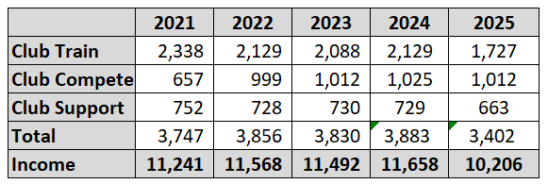
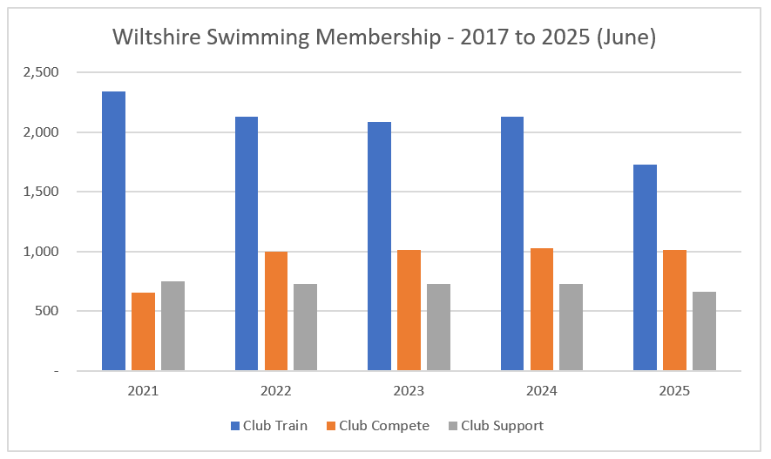
Monies collected so far from ASA total £10,206 [3 payments received in 2025]
INCOME / EXPENSES
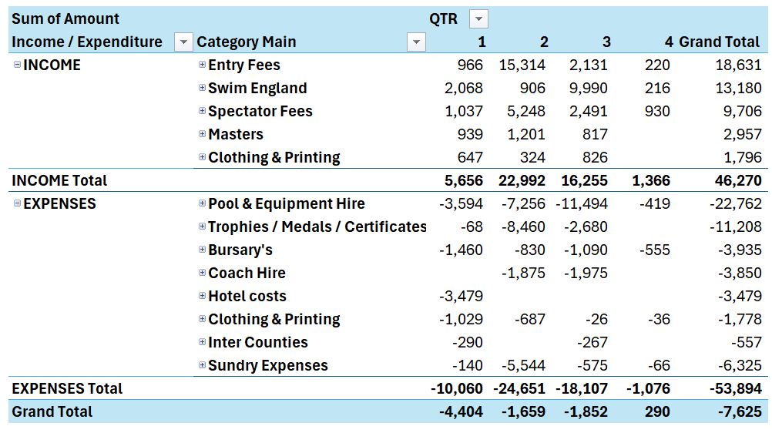
- Above table is prepared on a cash basis and covers the period 01 September to 30 June 2025. For the purposes of clarity, the following is denoted
- Q1 = Quarter 1 (September, October, November 2024)
- Q2 = Quarter 2 (December 2024, January & February 2025)
- Q3 = Quarter 3 (March, April, May 2025)
- Q4 = Quarter 4 (June 2025)
- Cash on hand is fairly static over the period (-£7,625 in the year), the following graph shows the movements
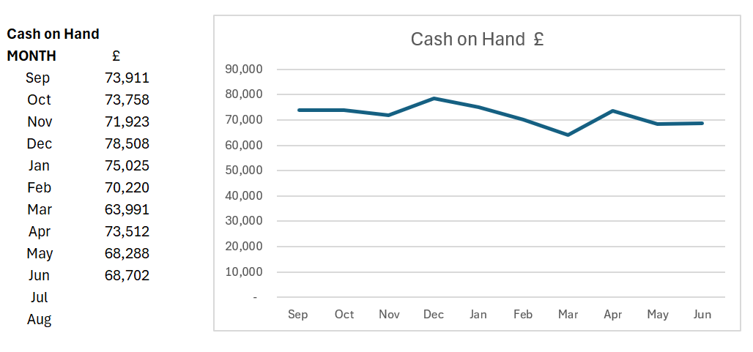
- As mentioned, the total outflow is £7,265 so far in the year. Note the cash balance is measured from the closing balance in August £76,327.
- I have tidied up the narratives a little bit since the last report and I think this is clearer and more functional, all main categories can be broken down further, and these are shown in the appendix attached. In the interests of timings, I do not propose to go through these at this time, but welcome questions on email if there are items of note.
- Any other feedback on format and content is welcomed.

OTHER MATTERS
- We have now had 3 receipts in from Swim England ASA, membership numbers particularly in the club train category have dropped a little. As part of the exit notes from the Swimmers that have left my home club there seems to be 2 main reasons for people dropping out of swimming.
- I have now had the control sheet in for the Dev Meet from Rob, there are a number of clubs that are yet to make good on their share of entry fees. I will be sending Rob a list but we are yet to receive a total of £2,448 from a total entry pool of £4,428.
- We are still carrying a large cash balance despite some abatement in the year. Are we comfortable with this level of cash holding or are there any suggestions that we can channel cash spend to that will be of benefit to our Wiltshire clubs.
- For example, throwing one idea out there… If Wiltshire invested in a new starter system, that works across the various timing systems, we as the county could easily afford the capital outlay needed and then would look to recoup some of that over time with a per gala charge. This would take some strain away from clubs that have ageing/unreliable systems and standardise the starting system across the majority of Wiltshire swimming. If a project like this is of interest, I will collate some information and present at the next exec meeting.
- I would also welcome other suggestions that would work across all the disciplines if that would be a worthwhile exercise too.
- Also mentioned previously, I do not have a handle on the level of medals and trophies we are carrying. In this financial year we have bought £11k worth. What I don’t know is how much of that we have consumed and how much is left “in stock” for future events. Would it be possible to please have a stock count and valuation report please as this would help improve the year end information somewhat. It should be noted that this will be a requirement for 31 August 2025 which is our year end, so please can we make sure this is assigned as an action, and this is done with the counts returned to me soon after that date.
Appendix 1 – further breakdown of income/costs
