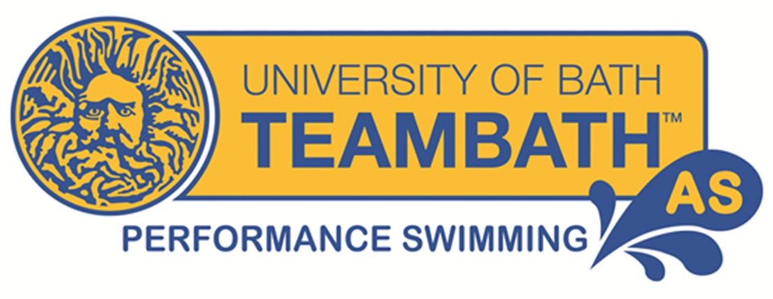
Patrons: Sharron Davies MBE, Stephanie Millward MBE

Development Coach Position at Team Bath AS

Team Bath AS now offers the most comprehensive pathway for swimmers in the Bath area, delivering a unique performance pathway from the end of Learn to Swim lessons right through to International success. It’s an exciting time to join our Coaching Team and as our Development Coach. You will work under the direction of our Performance Swimming Head Coach to help shape the athletes of the future and develop our vision for the club.

You’ll enjoy working with younger swimmers and have a passion for developing them as individuals and athletes. As an open-minded and progressive coach, you’ll relish being part of an enthusiastic and energetic team, welcoming new opportunities to grow your experience and mind set, while patiently inspiring our swimmers to be the best they can be.

You’ll be motivated, organised and be able to offer the flexibility to cover both training and competitions, while actively assisting the Coaching Team with day to day activities and future areas of development for the club, especially with the recent launch of the Team Bath AS Academy Swimming programme. The role would be mainly providing coaching for this squad. It is a progressive role and we are seeking an individual who wants to commit to the club and be an integral part of our growth going forward. There may be the opportunity to increase the hours and attend competitions.

Key details:
Hours: The position will involve evening and weekend hours with an immediate start for 5-6 hours per week. To provide continuity for swimmers, we would need a regular commitment at the same times each week.
Location: University of Bath, Sports Training Village and various sites in the surrounding area.
Employment: This role is part-time and offered on a self-employed basis.
Remuneration: This is negotiable dependant on qualifications and experience you may have.

Essential Qualifications:
- Swim England Swimming Coach (formerly the ASA Level 2 Coaching Swimming) qualification. Experienced Swim England Level 2 Swimming teachers that are willing to work towards the Level 2 coaching qualification may apply.

- Current Safeguarding and Protecting Children certificate

Desirable qualifications:
- National Pool Lifeguard qualification
- Other complimentary Swim England /ASA Coaching qualifications and teaching swimming qualifications
- Evidence of continued professional development (CPD)
- Clean driving licence

Skills/Attributes:
- A positive outlook
- Self-motivated
- An excellent communicator
- Ability to assess, record and report achievements
- Ability to plan and lead a safe, fun and effective class
- Having perseverance and patience
- Ability to encourage learners
- Reliable and able to provide cover for other coaches at short notice and arrange cover when appropriate
- Administration and IT skills
- Strong interpersonal skills and willingness to work effectively with the committee, its volunteers, swimmers, and other key stakeholders

Job description:
- To plan, deliver and evaluate a high quality annual training and competition programme with our Head Coach.
- To have commitment to attend CPD opportunities as appropriate.
- To have an up to date knowledge of all the technical rules of swimming.
- To ensure swimmers with potential are identified and offered the opportunity to join the Team Bath AS programme.
- To plan and coach training sessions for any allocated squad.
- To ensure accurate training records of the swimmers are maintained.
- To plan and establish realistic individual goals and objectives for each swimmer.
- To plan, attend and support swimmers at competitions including; open meets, Regionals, Nationals and any that may be required to attend.
- To attend meetings and/or submit reports as required by the Management Committee or Head Coach.
- To comply with the Policies of the Club.
- To have the ability to develop, implement and evaluate action plans.
- To have the ability to help the club meet financial targets and plan resources within budgets.
Team Bath AS is committed to safeguarding the welfare of children and young people and expects all staff to share this commitment and comply with the policies of the club. All appointments are subject to a satisfactory enhanced DBS check and reference.

To apply

Please visit our website to learn more about our club at teambathas.co.uk then send your CV and covering letter to secretary@teambathas.co.uk. Informal pre–arranged visits to club coaching sessions are welcome. The closing date is 23rd September 2018. Applicants will be expected to undergo a six month probationary period and be subject to a three month review.

