British Gas National County Team Championships
16 October 2011 at Ponds Forge, Sheffield

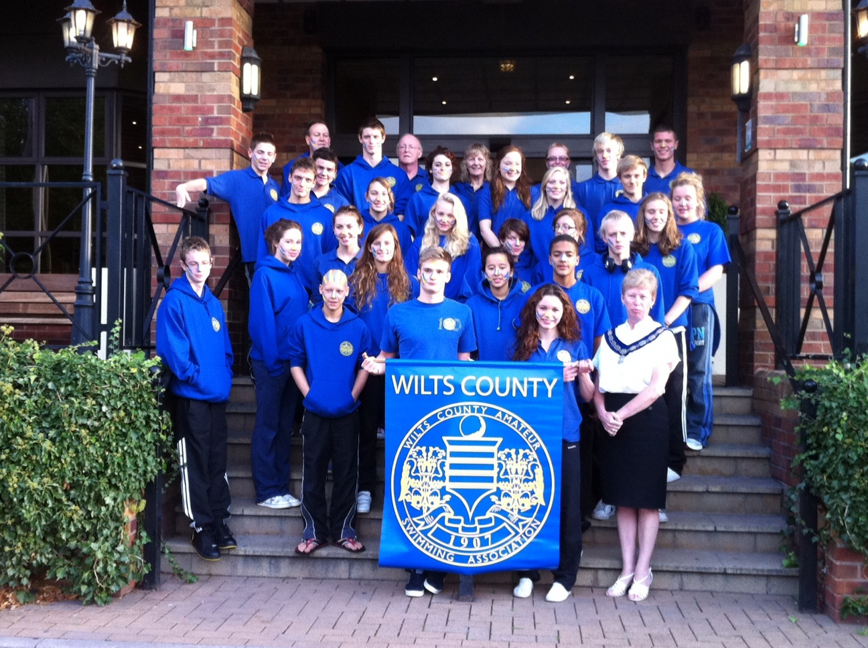

The Wiltshire Team consisting of twenty six swimmers, two coaches, two team managers and two officials travelled from Wroughton on the 15 October for an overnight stay in Rotherham prior to taking part in the National County Team Championships at Ponds Forge, Sheffield the following day.

At the Team meeting on the morning of 16 October the County President Maureen Dunbar presented the following swimmers Emma Davies, Emily Dixon, Rebecca Hawkins, Eleanor Hine, Georgina Pitts, Emily Weston, Adam Coleman, Luke Demetri, Kyle Gaskin, Matthew Hare, Matthew Harris, Noah Kirby with their first time badges and Samantha Berry with her five swim ribbon.

The team then made the short the journey to Ponds Forge for a 9.45am warm up. The parade of County Presidents, team captains representing the thirty eight Counties taking part with their County banners and Gala officials took place at 11.30am.

The division two, thirty one event, gala started promptly at mid-day with the team clocking up eleven personal best times in the first thirteen individual races. The next three events were 4 x 50m medley relays. All the relay teams performed really well with one team achieving a better than entered time. At this point there was a fifteen minute break which allowed spectators to get their voices back.

When the competition restarted there were a further eleven individual races with the team again in top form producing a further seven personal best times. The final four events were three 4 x 50m medley relays and the mixed 6 x 50m freestyle cannon. As before, all the relay teams performed well with two teams achieving a better than entered time.

Although the final results saw the team finish tenth the gala had produced eighteen personal best times from twenty four individual swims and three better than entered times from the seven relay events.

The whole team enjoyed the weekend. Every swimmer in the team gave 100% and the team spirit and camaraderie was fantastic.

For full results see following sheets.
Wiltshire County Team – Swimmers, Coaches, Team Managers & Officials.

Rebecca Hawkins Bradford-on-Avon
Eleanor Hine Bradford-on-Avon
Matthew Hare Chippenham
Melissa Birkett Corsham Team Captain Girls
Matthew Harris Corsham
Gemma Currie Salisbury
Luke Demetri Salisbury
Samuel Greenslade Salisbury
Samantha Berry Swindon Dolphin
Emily Dixon Swindon Dolphin
Charlotte Pitts Swindon Dolphin
Georgina Pitts Swindon Dolphin
Adam Coleman Swindon Dolphin
Liam Herbert Swindon Dolphin Team Captain Boys
Noah Kirby Swindon Dolphin
Mathew Sambrook Swindon Dolphin
Emma Davies Trowbridge
Nichole Esdaile Trowbridge
Chloe Flower Trowbridge
Katie Pugh Trowbridge
Daniella Whiting Trowbridge
Harry Ash Trowbridge
Ricky Griggs Trowbridge
Aaron Moores Trowbridge
Emily Weston Tigersharks
Kyle Gaskin Tigersharks

Andrew Higgins Wroughton Coach Boys
Debbie German Tigersharks Coach Girls

Stuart Bremner Warminster Team Manager Boys
Margaret Smith Bradford on Avon Team Manager Girls

Mike Greenan Trowbridge Official
Andrew Johnstone Tigersharks Official

 | Wiltshire ASA County Team 16th October 2011 Ponds Forge Sheffield
No: | Event | Swimmer | Entered Time | R Time | 50m Split | Finish Time | Pos
1 | Girls 16/17 100m Freestyle | Emily Weston | 1:01.76 | +1.29 | 28.62 | 59.79 | 11
2 | Boys 16/17 100m Freestyle | Henry Ash | 52.89 | +0.70 | 24.82 | 51.66 | 1
3 | Girls 12/13 100 Breaststroke | Rebecca Hawkins | 1:21.66 | +0.90 | 38.58 | 1:21.29 | 15
4 | Boys 12/13 100 Breaststroke | Luke Demetri | 1:16.71 | +0.77 | 35.25 | 1:12.98 | 2
5 | Girls 14/15 100m Butterfly | Samantha Berry | 1:06.57 | +0.66 | 31.02 | 1:06.14 | 3
6 | Boys 14/15 100m Butterfly | Ricky Griggs | 1:07.76 | +0.92 | 30.97 | 1:03.75 | 11
7 | Girls 16/17 100m Backstroke | Melissa Birkett | 1:08.30 | +0.70 | 32.86 | 1:07.84 | 8
8 | Boys 16/17 100m Backstroke | Liam Herbert | 58.58 | +0.59 | 28.45 | 58.52 | 5
9 | Girls 12/13 100m Freestyle | Georgina Pitts | 1:02.59 | -.- | 30.12 | 1:02.69 | 9
10 | Boys 12/13 100m Freestyle | Noah Kirby | 1:01.85 | +0.79 | 28.37 | 1:00.14 | 9
11 | Girls 14/15 100 Breaststroke | Daniella Whiting | 1:16.29 | -.- | 36.25 | 1:13.98 | 3
12 | Boys 14/15 100 Breaststroke | Samuel Greenslade | 1:15.32 | -.- | 34.82 | 1:15.03 | 17
13 | Girls 16/17 100m Butterfly | Melissa Birkett | 1:08.10 | +0.94 | 31.47 | 1:08.57 | 14
14 | Boys 16/17 4 x 50m Medley Relay  Entered Time 1:52.80 | Liam Herbert | 28.45 | +0.28 | 28.34
14 | Boys 16/17 4 x 50m Medley Relay  Entered Time 1:52.80 | Aaron Moores | 31.27 | +0.41 | 31.06
14 | Boys 16/17 4 x 50m Medley Relay  Entered Time 1:52.80 | Kyle Gaskin | 28.98 | +0.97 | 29.51
14 | Boys 16/17 4 x 50m Medley Relay  Entered Time 1:52.80 | Henry Ash | 24.10 | +0.58 | 23.94 | 1:52.85 | 13
15 | Girls 12/13 4 x 50m Medley Relay  Entered Time 2:09.79 | Eleanor Hine | 31.87 | +0.71 | 32.06
15 | Girls 12/13 4 x 50m Medley Relay  Entered Time 2:09.79 | Rebecca Hawkins | 38.30 | +0.48 | 38.77
15 | Girls 12/13 4 x 50m Medley Relay  Entered Time 2:09.79 | Chloe Flower | 30.83 | +0.81 | 32.75
15 | Girls 12/13 4 x 50m Medley Relay  Entered Time 2:09.79 | Georgina Pitts | 28.79 | +0.62 | 29.96 | 2:13.54 | 13
16 | Boys 14/15 4 x 50m Medley Relay  Entered Time 2:01.65 | Mathew Sambrook | 30.26 | +0.69 | 30.08
16 | Boys 14/15 4 x 50m Medley Relay  Entered Time 2:01.65 | Samuel Greenslade | 34.52 | +0.52 | 33.76
16 | Boys 14/15 4 x 50m Medley Relay  Entered Time 2:01.65 | Ricky Griggs | 29.49 | +0.62 | 29.35
16 | Boys 14/15 4 x 50m Medley Relay  Entered Time 2:01.65 | Matthew Harris | 27.38 | +0. | 26.70 | 1:59.99 | 15
17 | Boys 16/17 100m Butterfly | Liam Herbert | 59.18 | +0.68 | 27.90 | 1:00.18 | 15
18 | Girls 12/13 100m Backstroke | Eleanor Hine | 1:08.07 | +0.70 | 32.75 | 1:07.78 | 5
19 | Boys 12/13 100m Backstroke | Adam Coleman | 1:08.81 | +0.64 | 32.84 | 1:08.35 | 10
20 | Girls 14/15 100m Freestyle | Charlotte Pitts | 1:01.09 | +0.82 | 29.23 | 1:00.35 | 10
21 | Boys 14/15 100m Freestyle | Mathew Sambrook | 57.77 | +0.76 | 26.82 | 56.35 | 9
22 | Girls 16/17 100m Breaststroke | Nichole Esdaile | 1:16.32 | +1.13 | 36.17 | 1:17.42 | 10
23 | Boys 16/17 100 Breaststroke | Aaron Moores | 1:08.89 | +0.91 | 32.43 | 1:08.97 | 9
24 | Girls 12/13 100m Butterfly | Chloe Flower | 1:06.63 | +0.81 | 33.30 | 1:11.10 | 8
25 | Boys 12/13 100m Butterfly | Matthew Hare | 1:11.84 | +0.79 | 32.90 | 1:09.17 | 11
26 | Girls 14/15 100m Backstroke | Daniella Whiting | 1:07.76 | +0.62 | 32.73 | 1:06.24 | 6
27 | Boys 14/15 100m Backstroke | Mathew Sambrook | 1:02.91 | -.- | 30.81 | 1:02.80 | 5

No: | Event | Swimmer | Entered Time | R Time | 50m Split | Finish Time | Pos
28 | Girls 16/17 4 x 50m Medley Relay  Entered Time 2:06.43 | Melissa Birkett | 32.48 | +0.62 | 31.95
28 | Girls 16/17 4 x 50m Medley Relay  Entered Time 2:06.43 | Nichole Esdaile | 36.11 | +0.18 | 34.87
28 | Girls 16/17 4 x 50m Medley Relay  Entered Time 2:06.43 | Katie Pugh | 29.90 | +0.34 | 29.16
28 | Girls 16/17 4 x 50m Medley Relay  Entered Time 2:06.43 | Gemma Currie | 27.94 | +0.67 | 28.20 | 2:04.18 | 5
29 | Boys 12/13 4 x 50m Medley Relay  Entered Time 2:07.16 | Adam Coleman | 32.77 | +0.66 | 32.94
29 | Boys 12/13 4 x 50m Medley Relay  Entered Time 2:07.16 | Luke Demitri | 36.06 | +0.39 | 33.89
29 | Boys 12/13 4 x 50m Medley Relay  Entered Time 2:07.16 | Matthew Hare | 30.81 | +0.42 | 30.73
29 | Boys 12/13 4 x 50m Medley Relay  Entered Time 2:07.16 | Noah Kirby | 27.52 | +0.49 | 27.00 | 2:04.56 | 6
30 | Girls 14/15 4 x 50m Medley Relay  Entered Time 2:06.44 | Emma Davies | 32.05 | +0.61 | 31.85
30 | Girls 14/15 4 x 50m Medley Relay  Entered Time 2:06.44 | Daniella Whiting | 35.40 | -.- | 35.69
30 | Girls 14/15 4 x 50m Medley Relay  Entered Time 2:06.44 | Emily Dixon | 31.21 | -.- | 31.38
30 | Girls 14/15 4 x 50m Medley Relay  Entered Time 2:06.44 | Charlotte Pitts | 27.78 | -.- | 27.91 | 2:06.83 | 9
31 | Mixed 6 x 50m Freestyle Relay  Entered Time 2:42.92 | Gemma Currie | 27.94 | +0.92 | 28.41
31 | Mixed 6 x 50m Freestyle Relay  Entered Time 2:42.92 | Georgina Pitts | 28.79 | +0.51 | 29.72
31 | Mixed 6 x 50m Freestyle Relay  Entered Time 2:42.92 | Noah Kirby | 27.52 | +0.42 | 26.53
31 | Mixed 6 x 50m Freestyle Relay  Entered Time 2:42.92 | Charlotte Pitts | 27.78 | +0.96 | 28.92
31 | Mixed 6 x 50m Freestyle Relay  Entered Time 2:42.92 | Samuel Greenslade | 26.79 | +0.51 | 25.48
31 | Mixed 6 x 50m Freestyle Relay  Entered Time 2:42.92 | Henry Ash | 24.10 | +0.55 | 24.42 | 2:43.69 | 12

