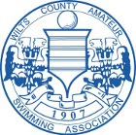
Wiltshire Swimmers On Record Breaking Form at DSE National SC Championships at Weekend.
Two world records, six European and 32 British records were broken at the weekend at the National DSE Short Course Championships , held at Ponds Forge , Sheffield.
With Paralympian stars such as Sasha Kindred, David Roberts, Liz Johnson, Stephanie Milward and Natalie Massey competing, it was poised to be a superb championship.
Day 1
In the first session, both Trowbridge ASC (S14) swimmers, Aaron Moores (17yrs) and Chloe Davies (12 yrs) dominated the 100m backstroke events. Aaron swam first and won gold with an outstanding time of 1.03.42 easily breaking the Male (S14) Short course record. His day continued with excellent swims in the 200m freestyle and 200IM collecting silver and bronze medals respectively.
Chloe’s first event of the Championships was also the 100m backstroke, and although a little nervous as she had not trained for the last 2 weeks through illness and with strong competition from many other S14 British Swimmers, Chloe was quietly confident as her entry time was fractionally quicker than anyone else. This did not seem to faze her and from the start began to pull away from the rest of the field. Chloe achieved a personal best time of 1:08.42 winning gold in a time that also more than 2 seconds inside the previous female S14 Short Course British Record.
Chloe continued the momentum by swimming a 4 second PB in the 200m freestyle that day and winning silver just behind her World Class Development team mate and current World Record holder in the 50 freestyle, Jessica Applegate.
In the 200IM, the final event of day one for Chloe, she was again in record breaking form. Chloe smashed the British Record again by more than 2 seconds in a time of 2:34.67.
Day 2
Aaron began this day with the 100m Breast stroke and what with Aaron already holding the 50m breast stroke record, he was keen to put in another good performance and was confident he could also get close to 100m Breastroke British Record. Aaron faced strong competition from Dan Pepper, (the current No. 1 S14 British swimmer) but still remained confident. Aaron had an great start with the fastest reaction time off the block and by 50m had began to create a lead over Dan Pepper. Whilst maintaining an excellent stroke rate, Aaron was in no mood to loose his lead and won gold in a time of 1.07.54 breaking another British Record.
Chloe then swam in the 100m breaststroke and again with good concentration gave Natalie Massey, the British No 1 female S14 swimmer ‘a run for her money’ by producing another personal best time by more than 4 seconds, securing her the silver medal, just behind Natalie Massey.
With the Paralympic Trials just around the corner, both swimmers are now back into full training and looking forward to the trials in March.
Continuing the Wiltshire success, huge congratulations also go to the newly classified S14 swimmer Craig Harris from Swindon Dolphins, who swam in his first ever DSE National SC championships. Swimming in the 100 freestyle and 100m backstroke, Craig smashed his previous Pb’s swimming amazingly and finished 7th in the 100m free and 100m backstroke events. After the early nerves from day 1, Craig on day 2 swam in the 100m breaststroke again improving significantly on his previous PBs and finished 8th in a class dominated by GBR swimmers several years older than Craig.
As a result of his earlier successes Craig was selected to be a key member of the South West Regional 400m Medley relay team and also the 400m Freestyle team.
Consisting of two Wiltshire swimmers the 4 x 100m medley relay team won Bronze with Aaron swimming the breast stroke leg and Craig on the final freestyle leg with tough competition from the Scottish and the East and West Midland regions.
Craig was also selected to swim the in the 4 x 100m freestyle relay team for the South West team, swimming alongside British No.2 (S14) swimmer Ben Procter, who had already swam and won the individual 100m freestyle event. Again swimming the final leg, Craig swam another PB bringing the team home to a Gold medal.
Huge Congratulations to Aaron, Chloe and Craig on outstanding swims whilst competing at the National DSE Short Course Championships for the South West Regional Team.
Nancy Davies (Wiltshire Disability liaison Officer) commented that “The best part of the weekend was seeing all the new talent emerging through from the South West Region. All the teams had some swimmers who were competing for the first time at a National event and everyone did so incredibly well. It really shows that Disability Swimming in the South West is growing and all the hard work that all the coaches, team managers and volunteers are doing is really making a difference”.
Looking forward the next big competitions are the Welsh LC Winter Open meet Championships on the 17th/18th December. British Champs/ Para Olympic Trials 3-10th March and then the DSE Junior Championships on the 24th/25th March 2012.
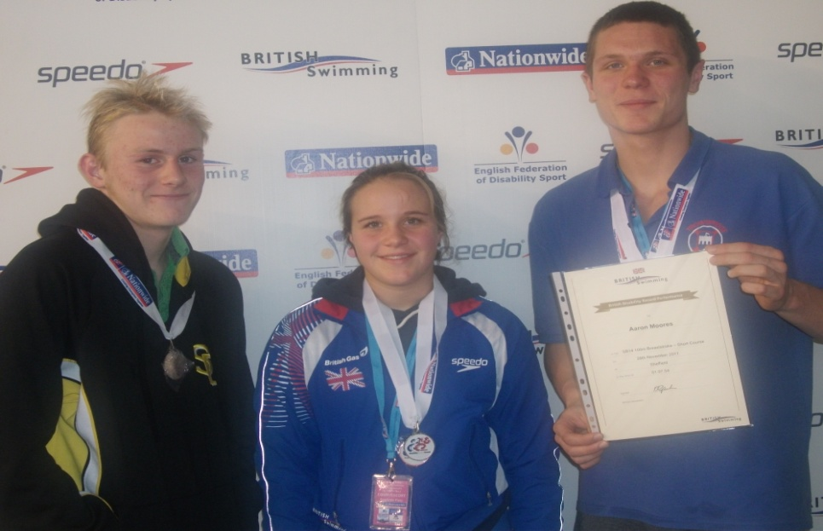

Wiltshire Swimmers from left to right- Craig Harris (12yrs) Swindon Dolphins, Chloe Davies (12 yrs) Trowbridge ASC, Aaron Moores ( 17yrs) Trowbridge ASC.

